User Manual

Group 37

Contents

Login 2

Register as New User 3

Login with Details 5

Profile 7

Dashboard 9

Start an Enrolled Course 10

Complete a Course (Quiz) 12

Courses 16

Enroll in a Course 17

Filter Courses 19

Leaderboard 23

Logout 24

# Login

To access the login page, use this link: <https://localhost:8443/login-form>

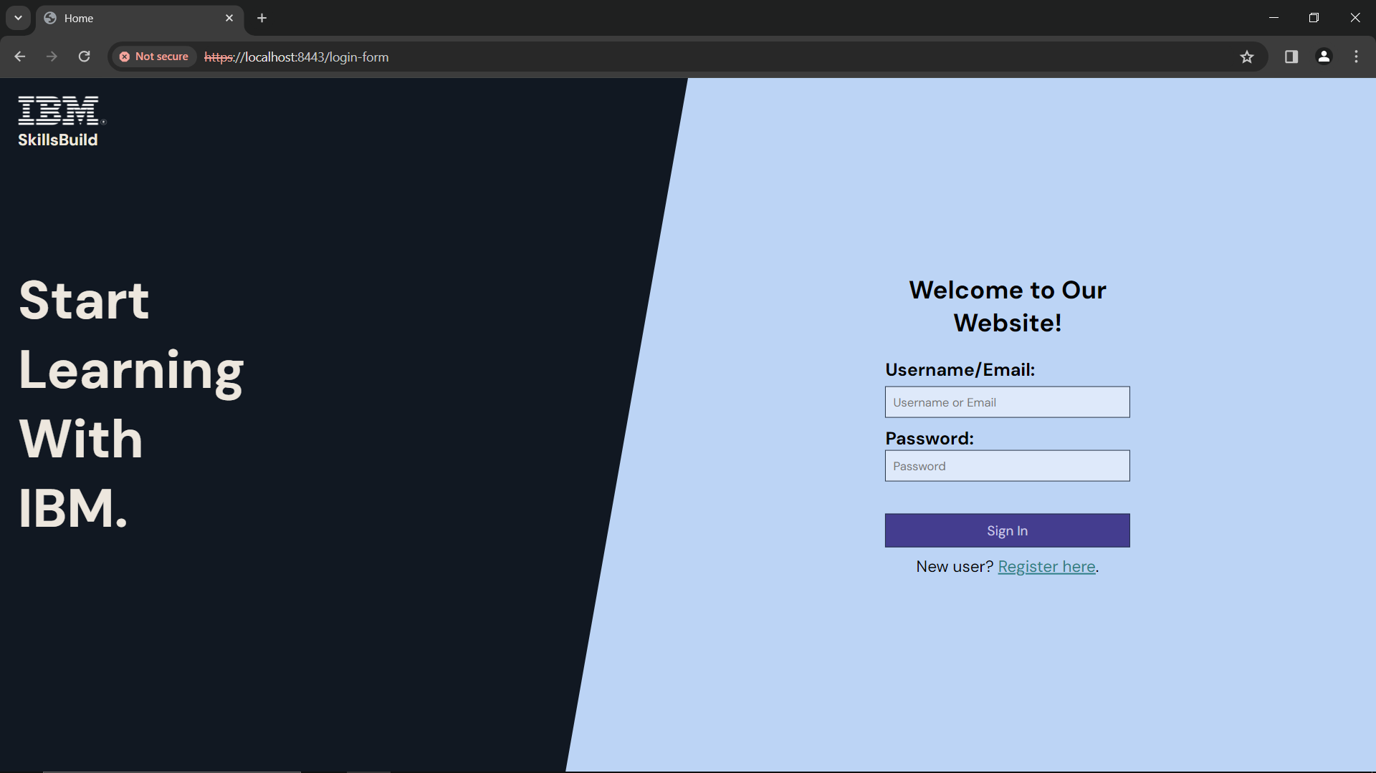

Figure 1: Login Page

If you already have an account, head to **Login** section under **Login** of the user manual.

If you don’t have an account, head to **Register as New User** section under **Login** of the user manual.

## Register as New User



Click here to register as new user

Figure 2: Login - Register Here

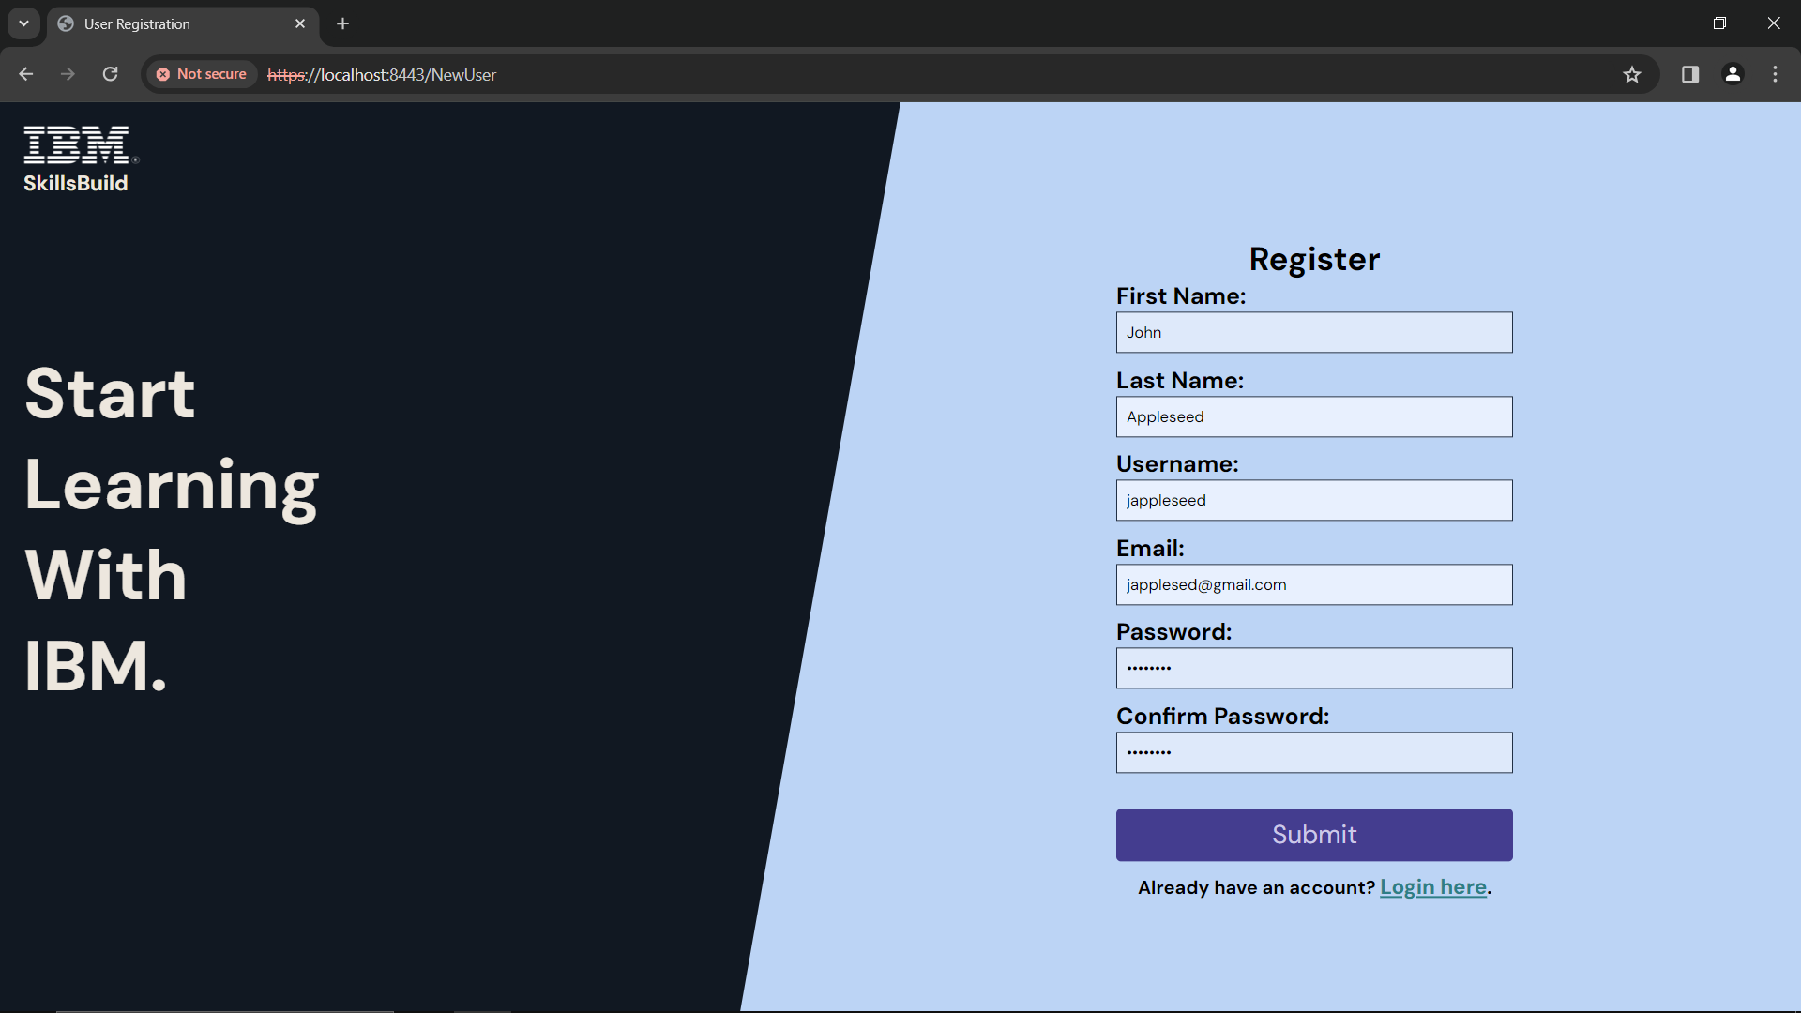

Once you have filled in your details, click ‘***submit***’

Your First Name

Your Last Name

A username of your choice

Your Email

A password of your choice

Repeat your password

Figure 3: New user

Fill in your details in each box

* Make sure **not** to leave any of the boxes **blank**
* Your first name must be **between 3-15 characters**
* Your last name must be **between 3-20 characters**
* Your username must be **between 4-20 characters**
* Your email address must follow pattern **example@example.com**
* Your password must be **between 8-32 characters** (e.g. *password*)
  + Make sure both passwords match

Make a note of your username and password - as you will need this to login to the website

After you click **‘*Submit’*** you will go back to the login page. Head to the **Login with Details** under the **Login** section of the user manual.

## Login with Details

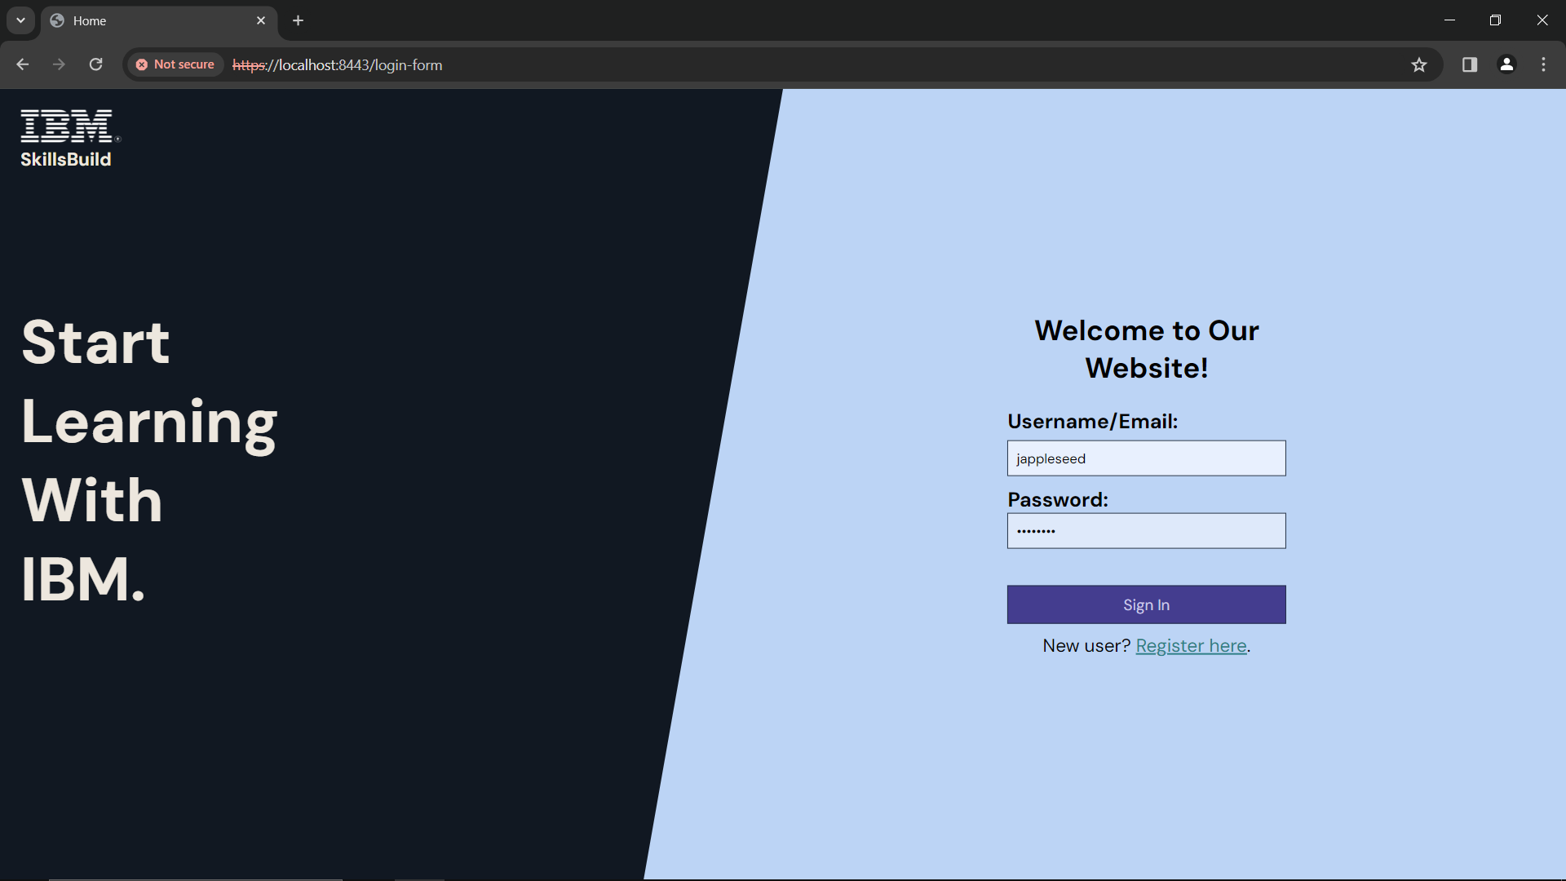

Enter your password

Enter your username

Once you are done, click **‘*Sign In*’**

Figure 4: Login – Sign In

Enter the details that you registered with and click **‘*Sign In’***

If your username or password is **incorrect**, you will see a **message that says, ‘Invalid Credentials!’**.

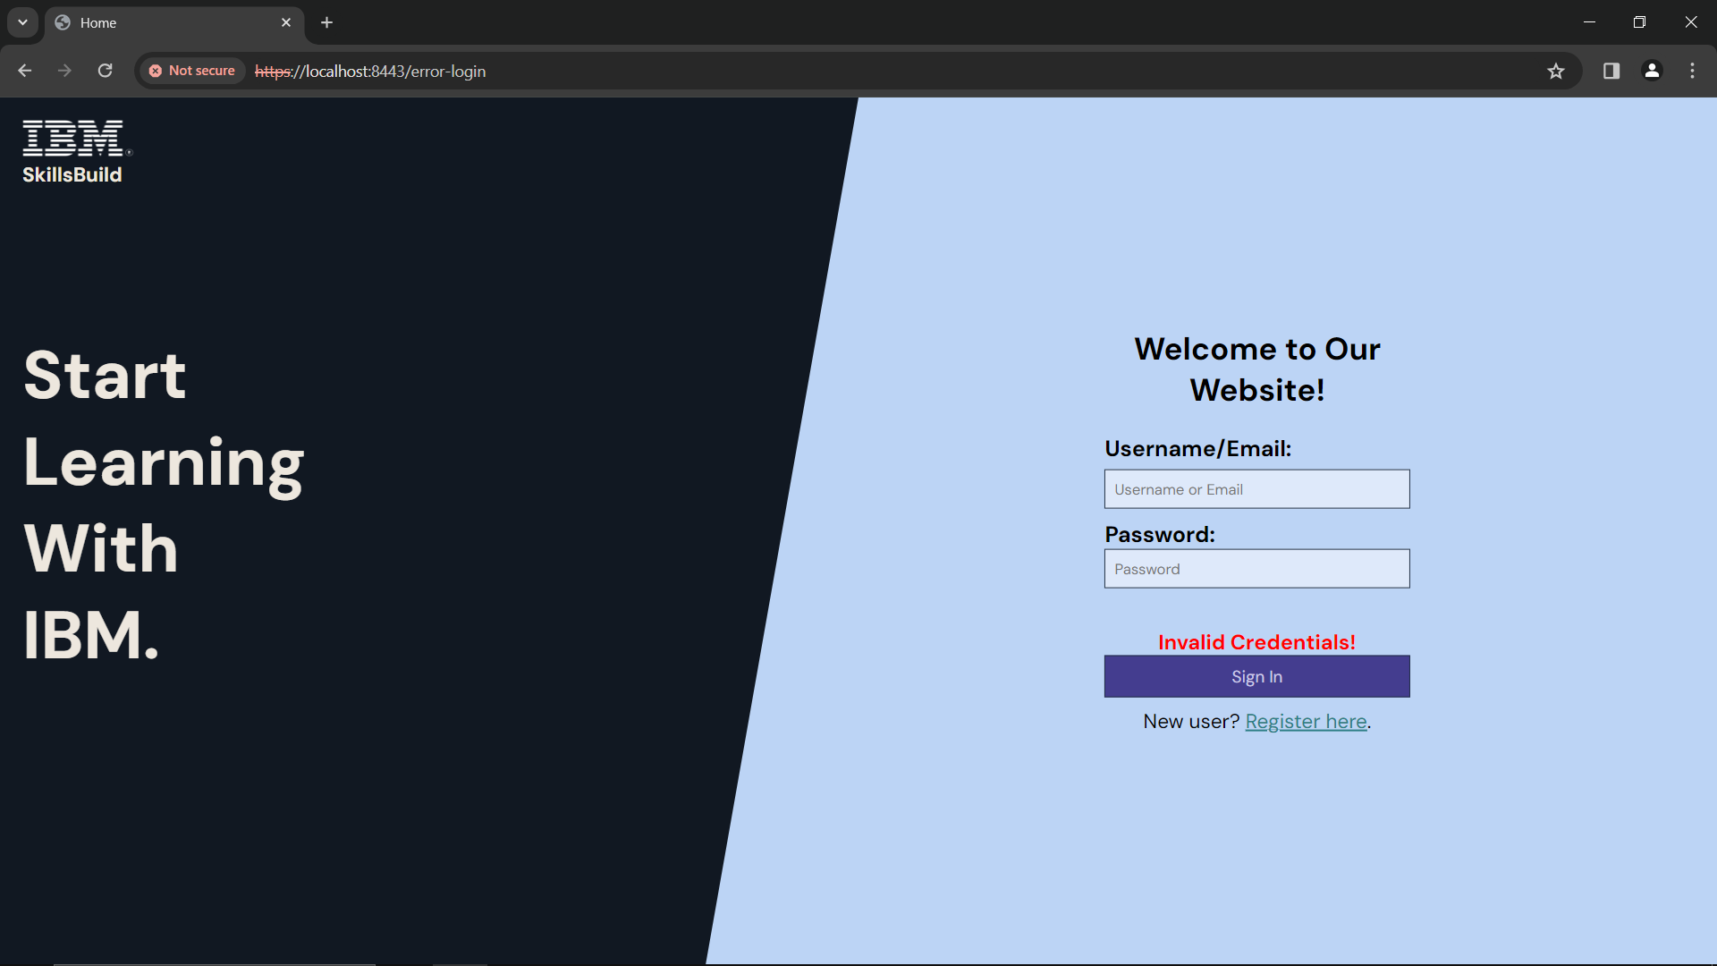

Figure 5: Login - 'Invalid Credentials'

* Enter your correct username and password

If your username and password are **correct**, you will see one of 2 pages:

* **Courses page** - if you are NOT enrolled in any courses

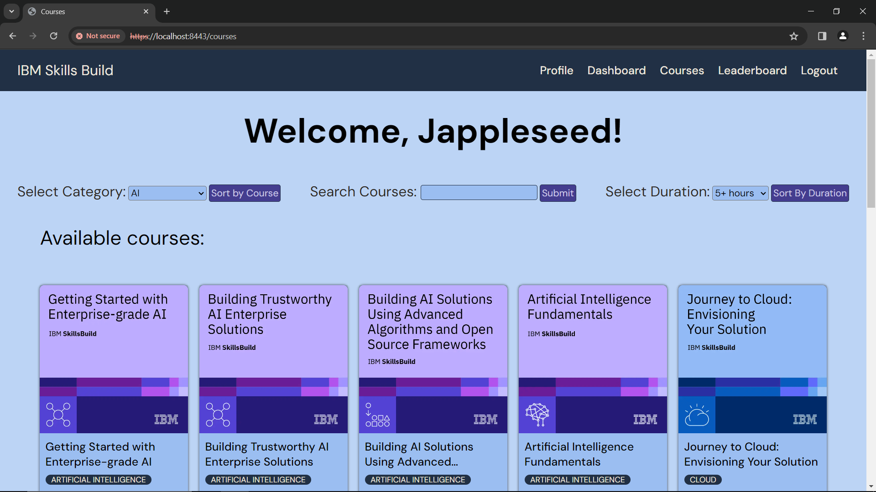

Figure 6: Courses

* **Dashboard** - if you are enrolled in any courses

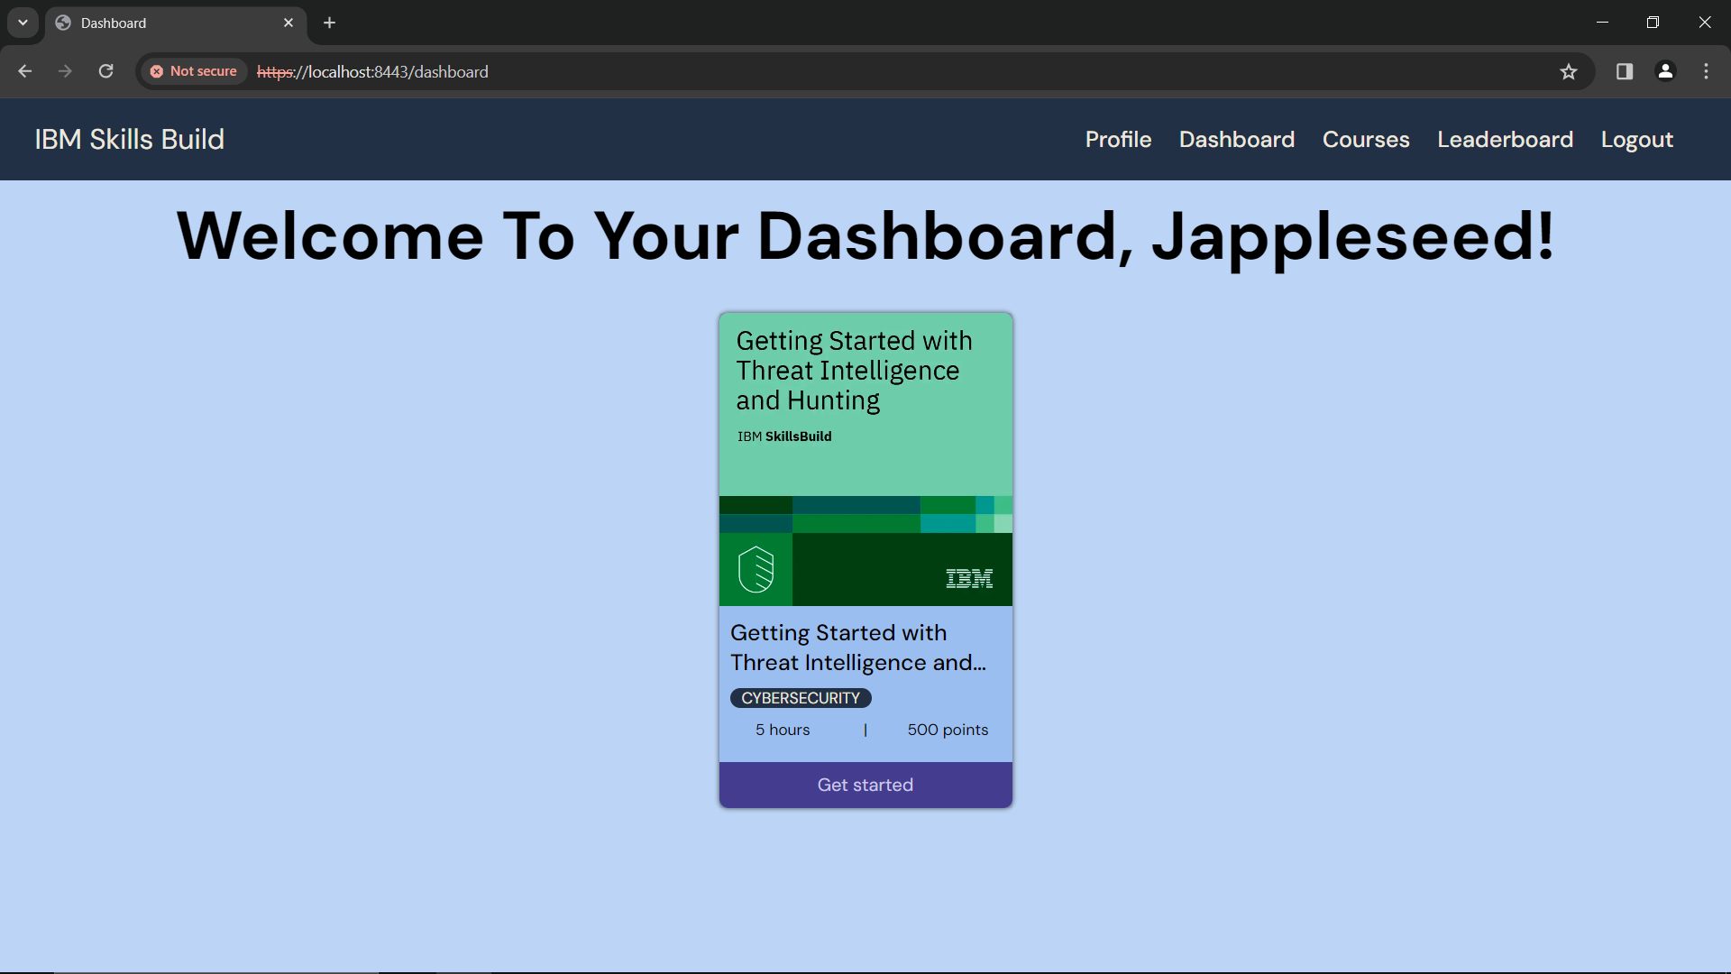

Figure 7: Dashboard

If you want help with logging out, head to the **Logout** section in the user manual.

# Profile

To access your profile page, use this link: <https://localhost:8443/profile>

In your profile, you will see your details – first name, last name, email address, username, course information, your leaderboard rank, and the hours left to complete

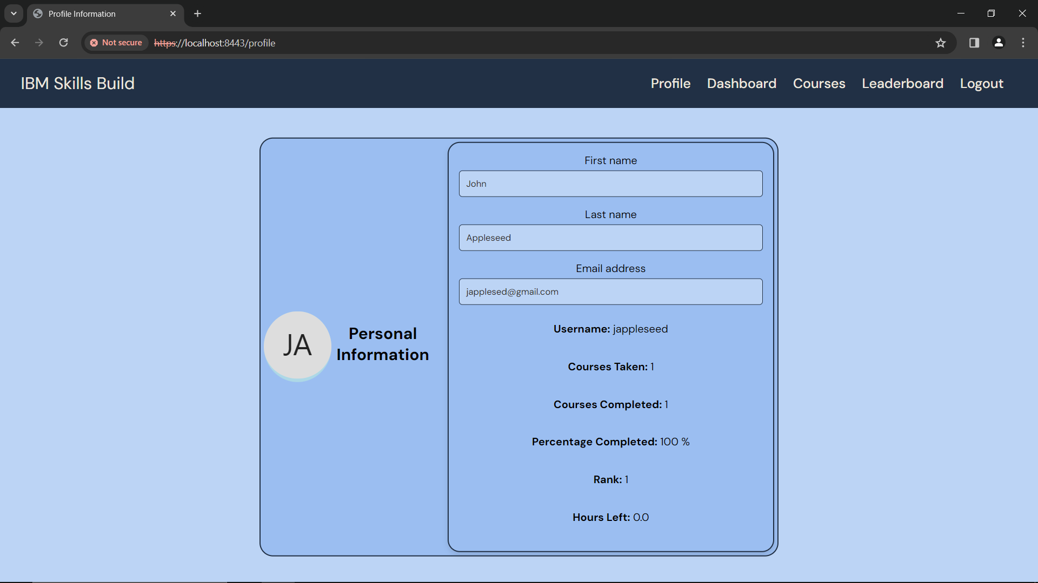

Figure 8: Profile

The courses information will update as you enroll in, and complete courses.

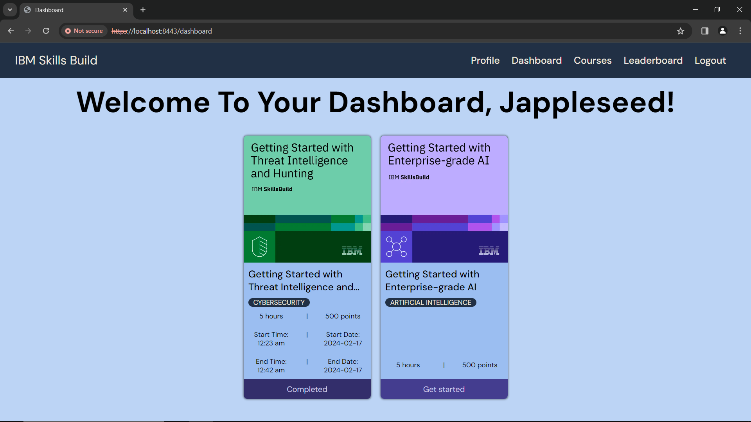

Figure 9: Dashboard - 2 courses

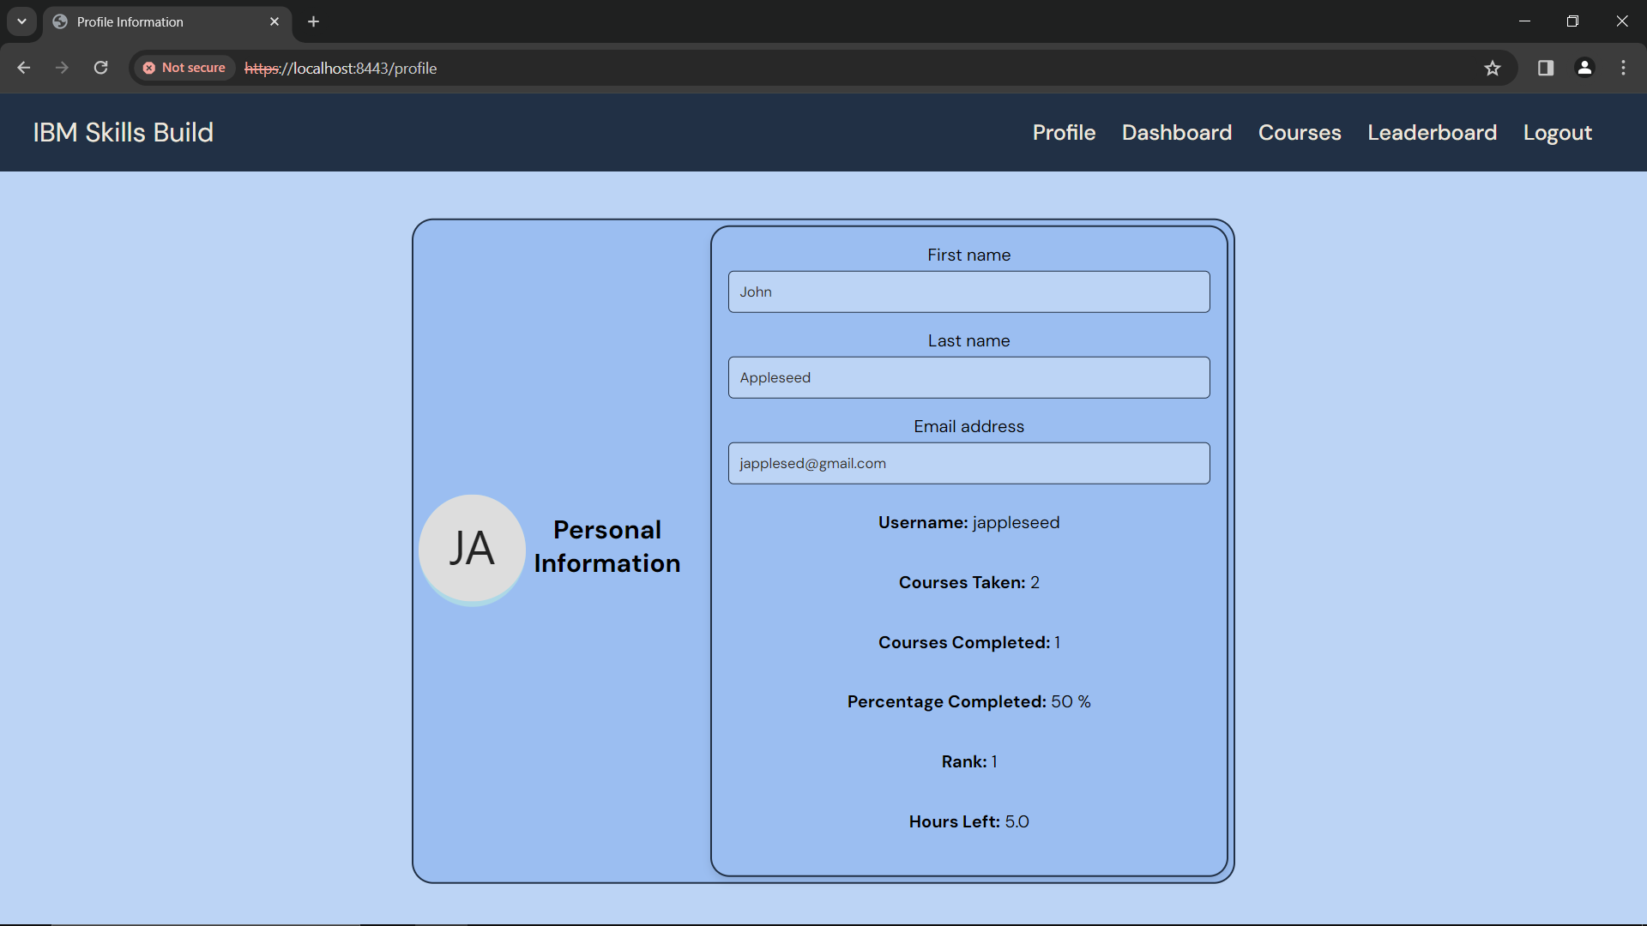

Figure 10: Profile reflecting 2 courses information

# Dashboard

To access your dashboard, use this link: <https://localhost:8443/dashboard>

On your dashboard, you will see a Welcome message, with the courses you have enrolled in.



Figure 11: Dashboard

If you have not enrolled in any courses, you will see this.

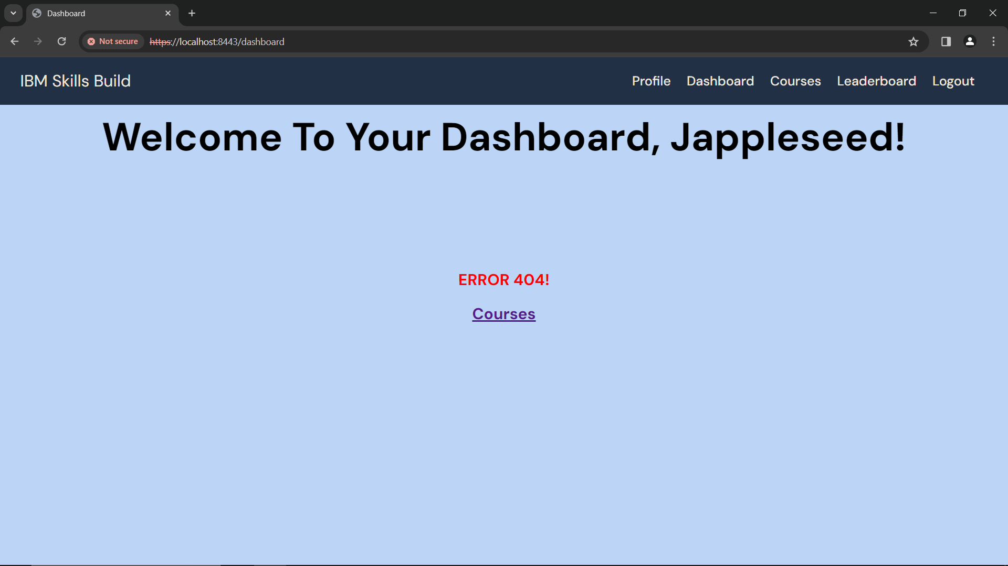

Figure 12: Dashboard – Not enrolled in any courses

## Start an Enrolled Course

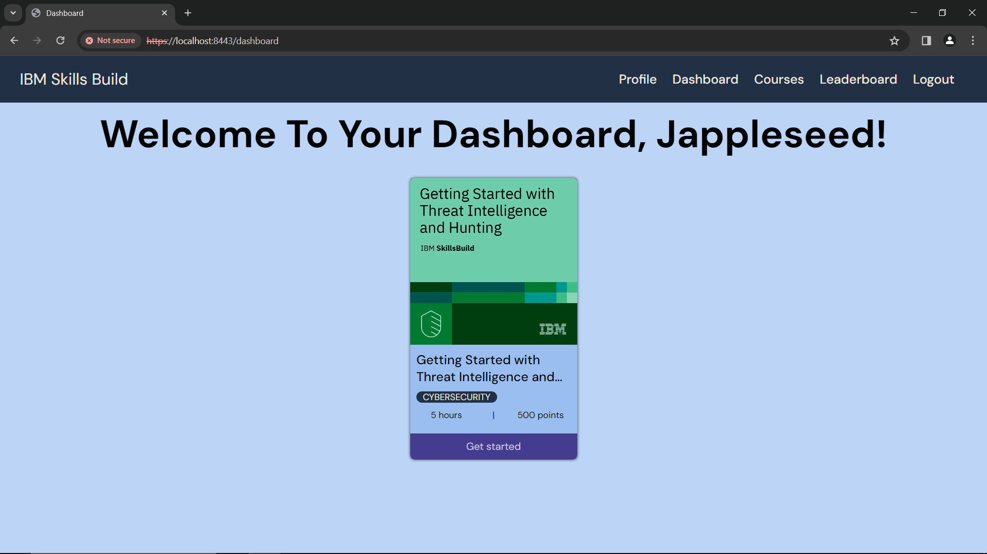

To start a course, click **‘*Get Started’***

Figure 13: Dashboard

In your dashboard, you will see the courses you have enrolled in.

To start a course, click the ***’Get Started’*** button under the course

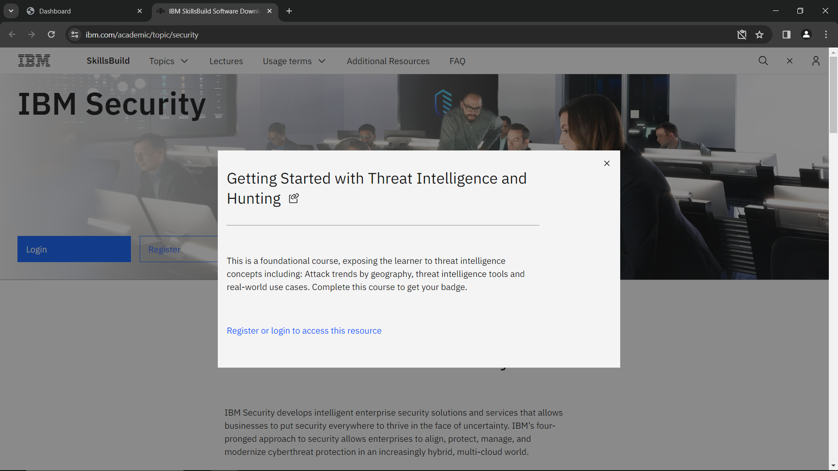

Figure 14: IBM Skillsbuild to begin course

You will be redirected to the IBM Skillsbuild website for that course.

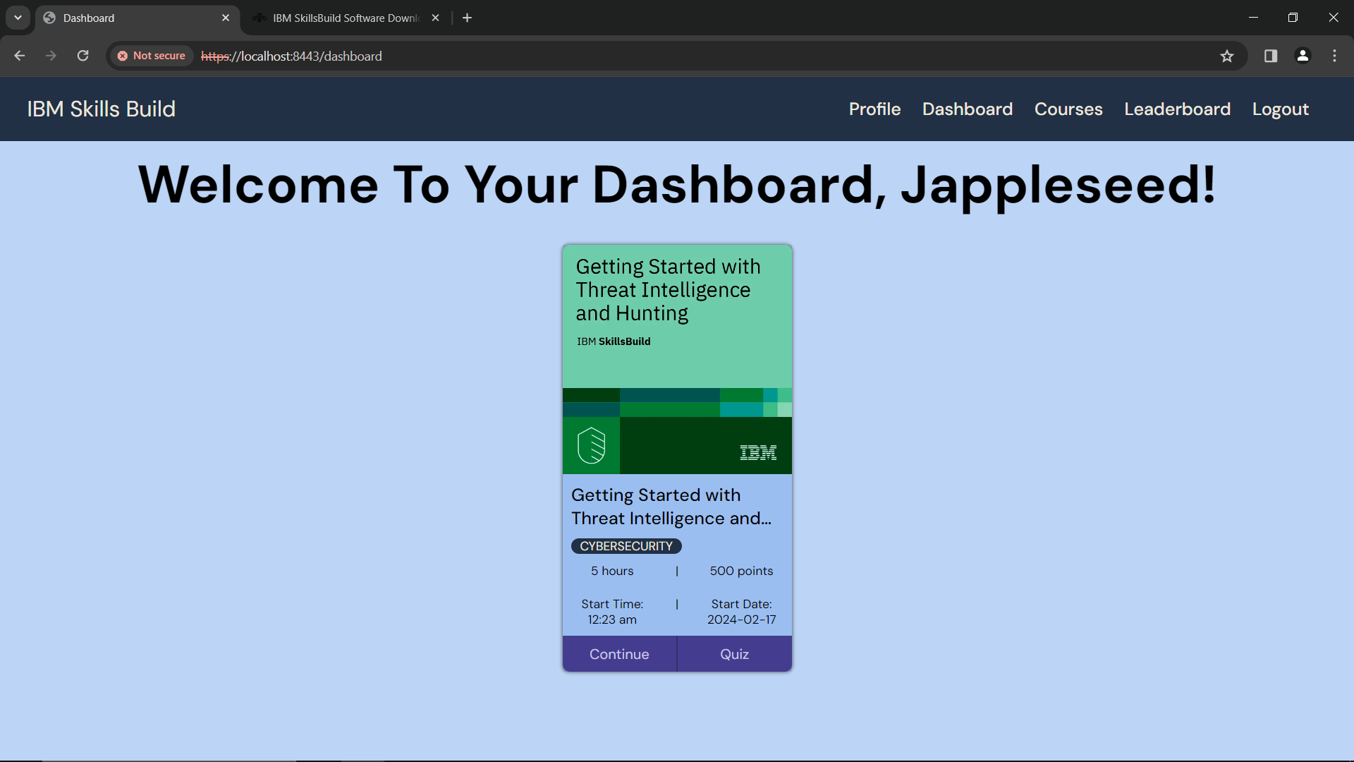

Figure 15: Dashboard - Course Start Time

In your dashboard, you will also be able to see the time and date of when you started the course.

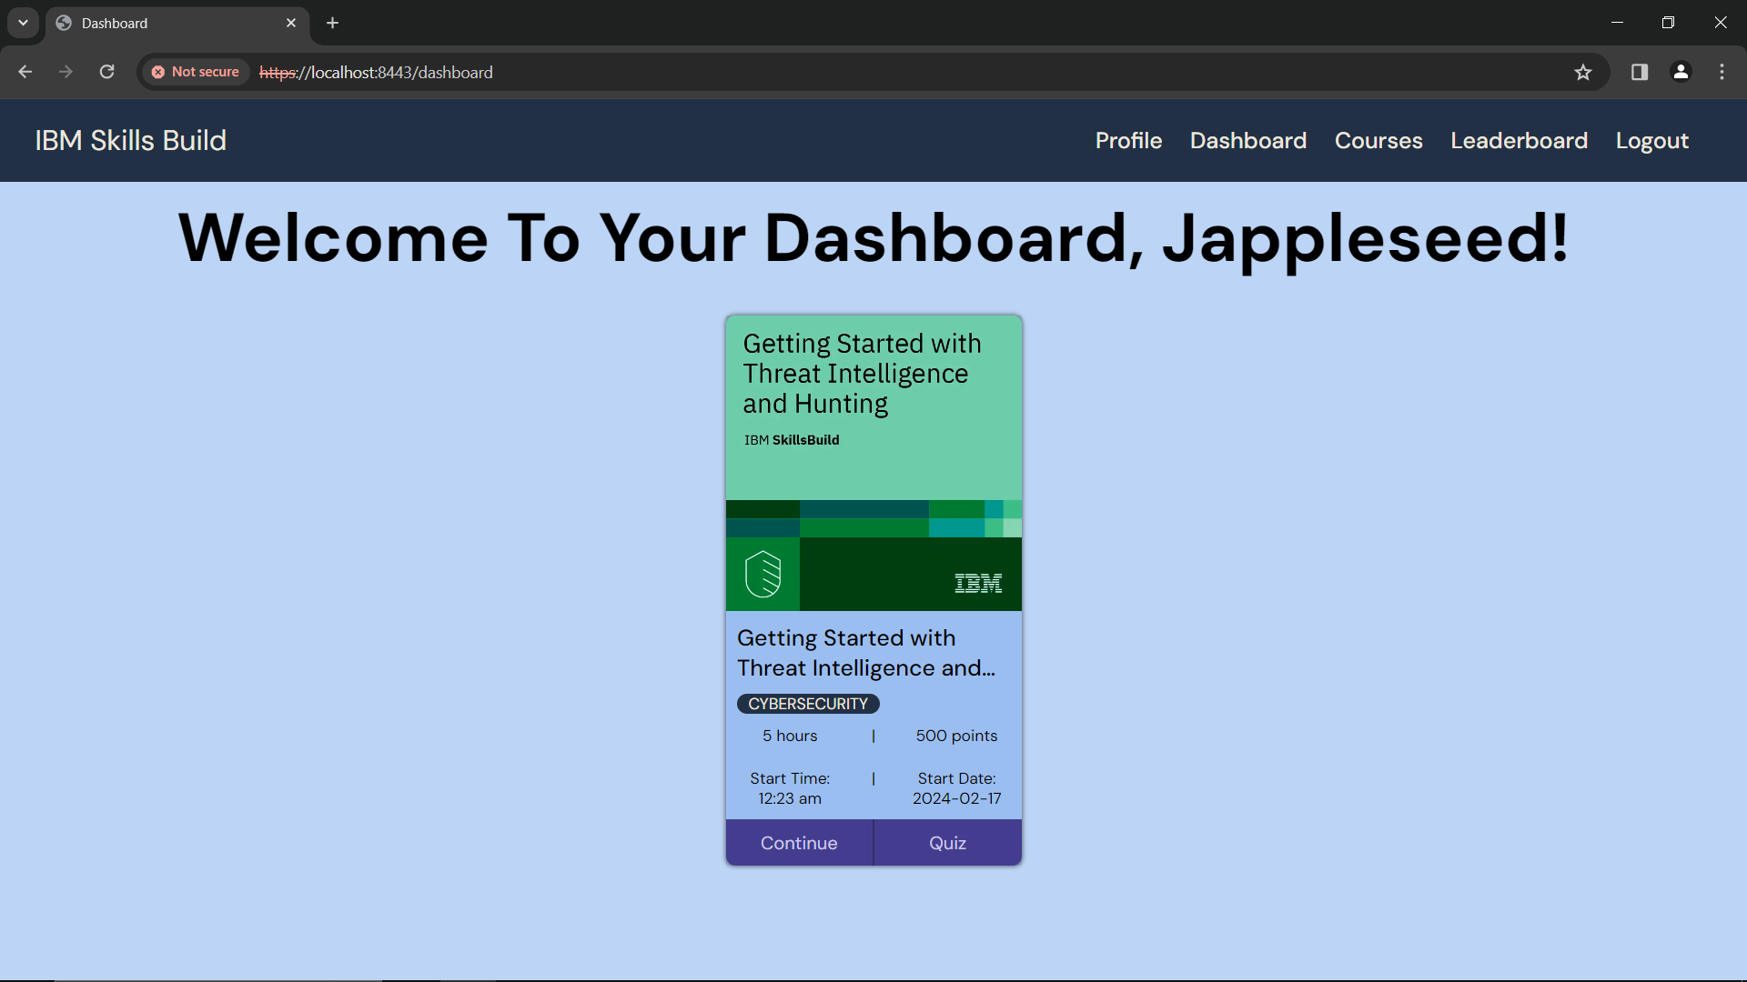

To continue a course, click **‘*Continue’***

Figure 16: Dashboard - Continue Course

To continue a course, click the ***‘Continue’*** button under the course

## Complete a Course (Quiz)

Once you have completed a course on IBM SkillsBuild, you will have to take a quiz to test your understanding.



Click ***‘Quiz’***, to test your understanding

Figure 17: Dashboard - Course Completion Quiz

Once you click on ***‘Quiz’***, you will see a quiz with 5 questions.

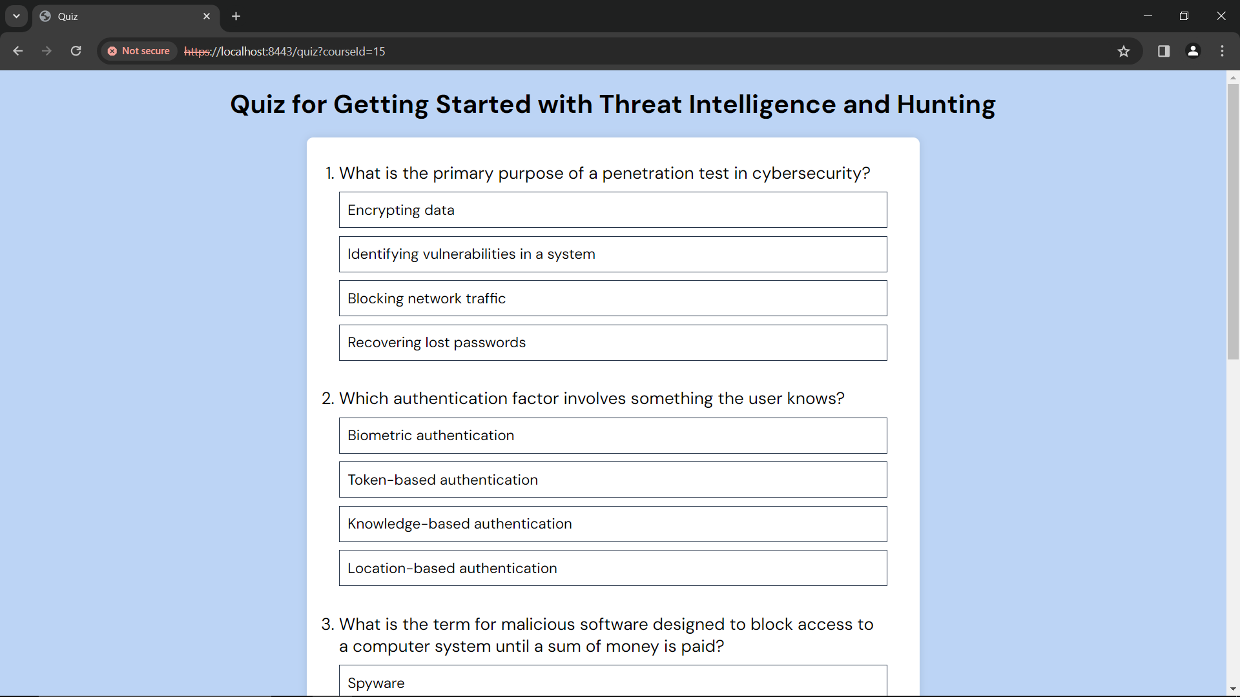

Figure 18: Quiz

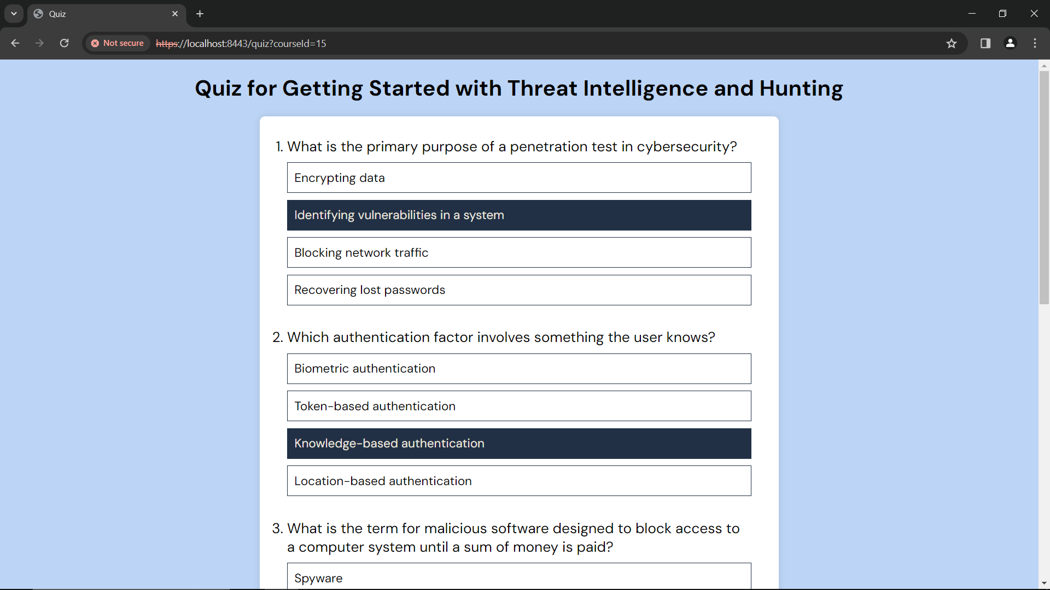

Figure 19: Quiz - Select answers

Select the correct option for each of the 5 questions

* You must answer **ALL** the questions

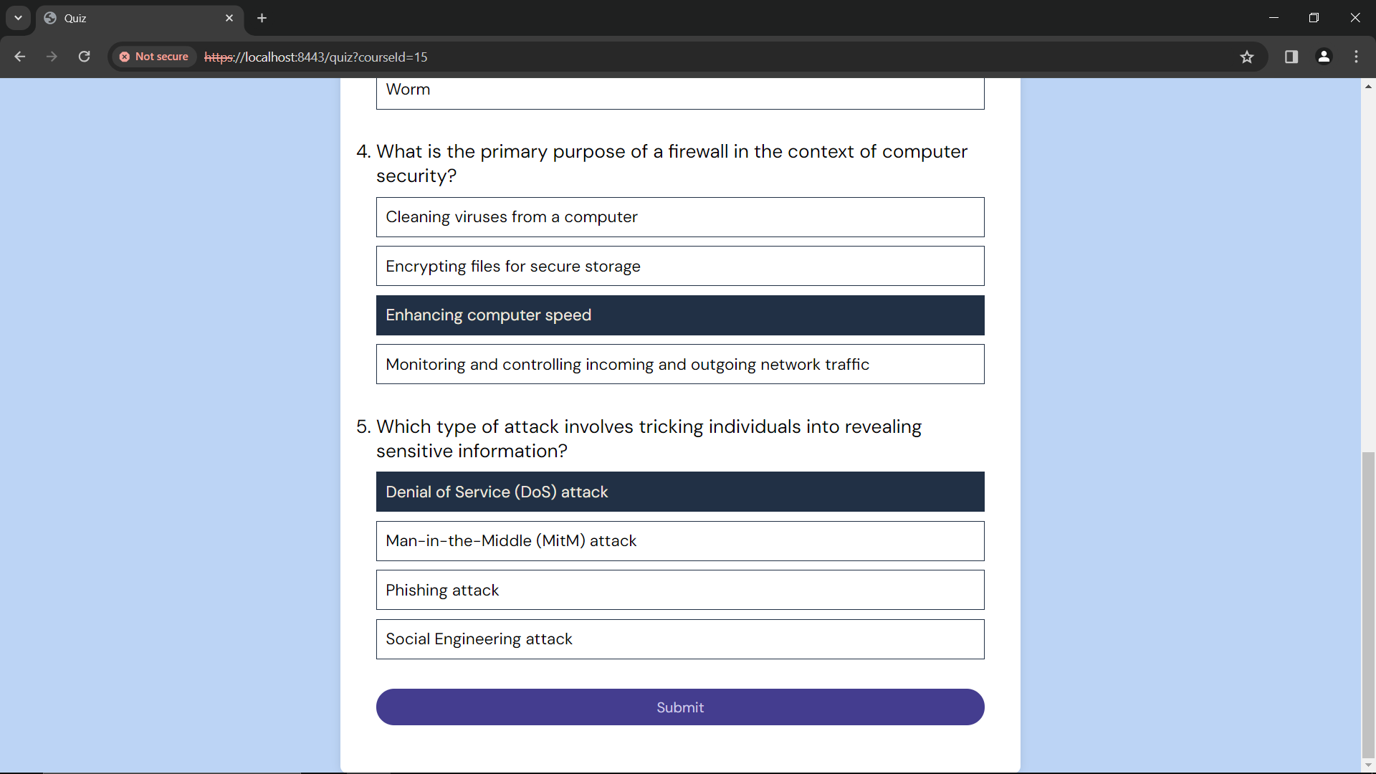

Click ***‘Submit’***, once you are done

Figure 20: Quiz - Submit

Once you are done, click ***‘Submit’***

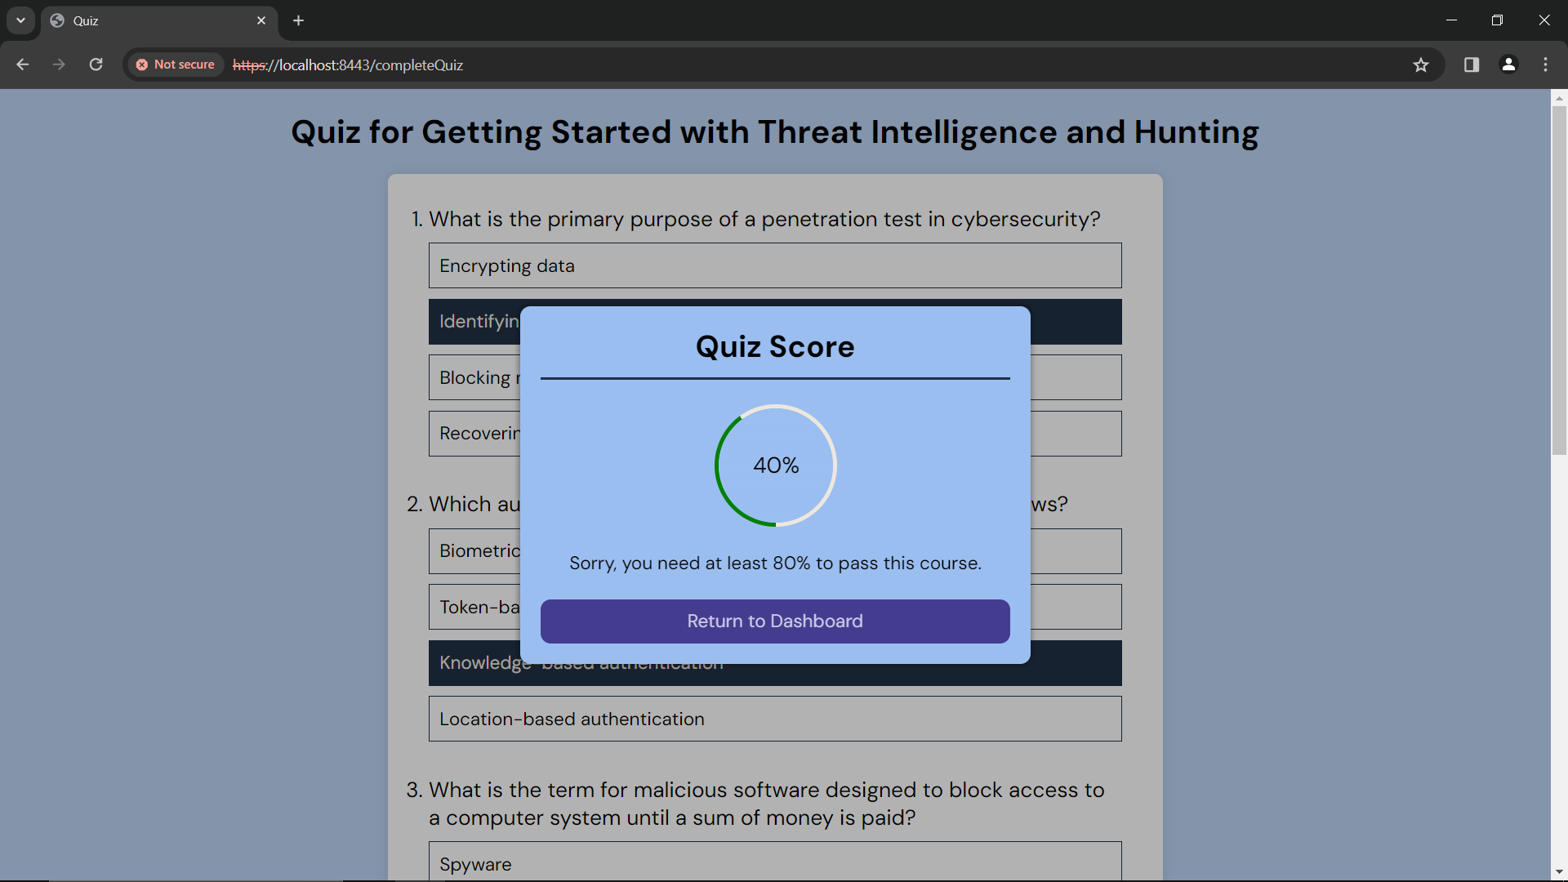

Figure 21: Quiz - Score

You will see your score

* You need **at least 80%** in the quiz to pass a course, and complete it

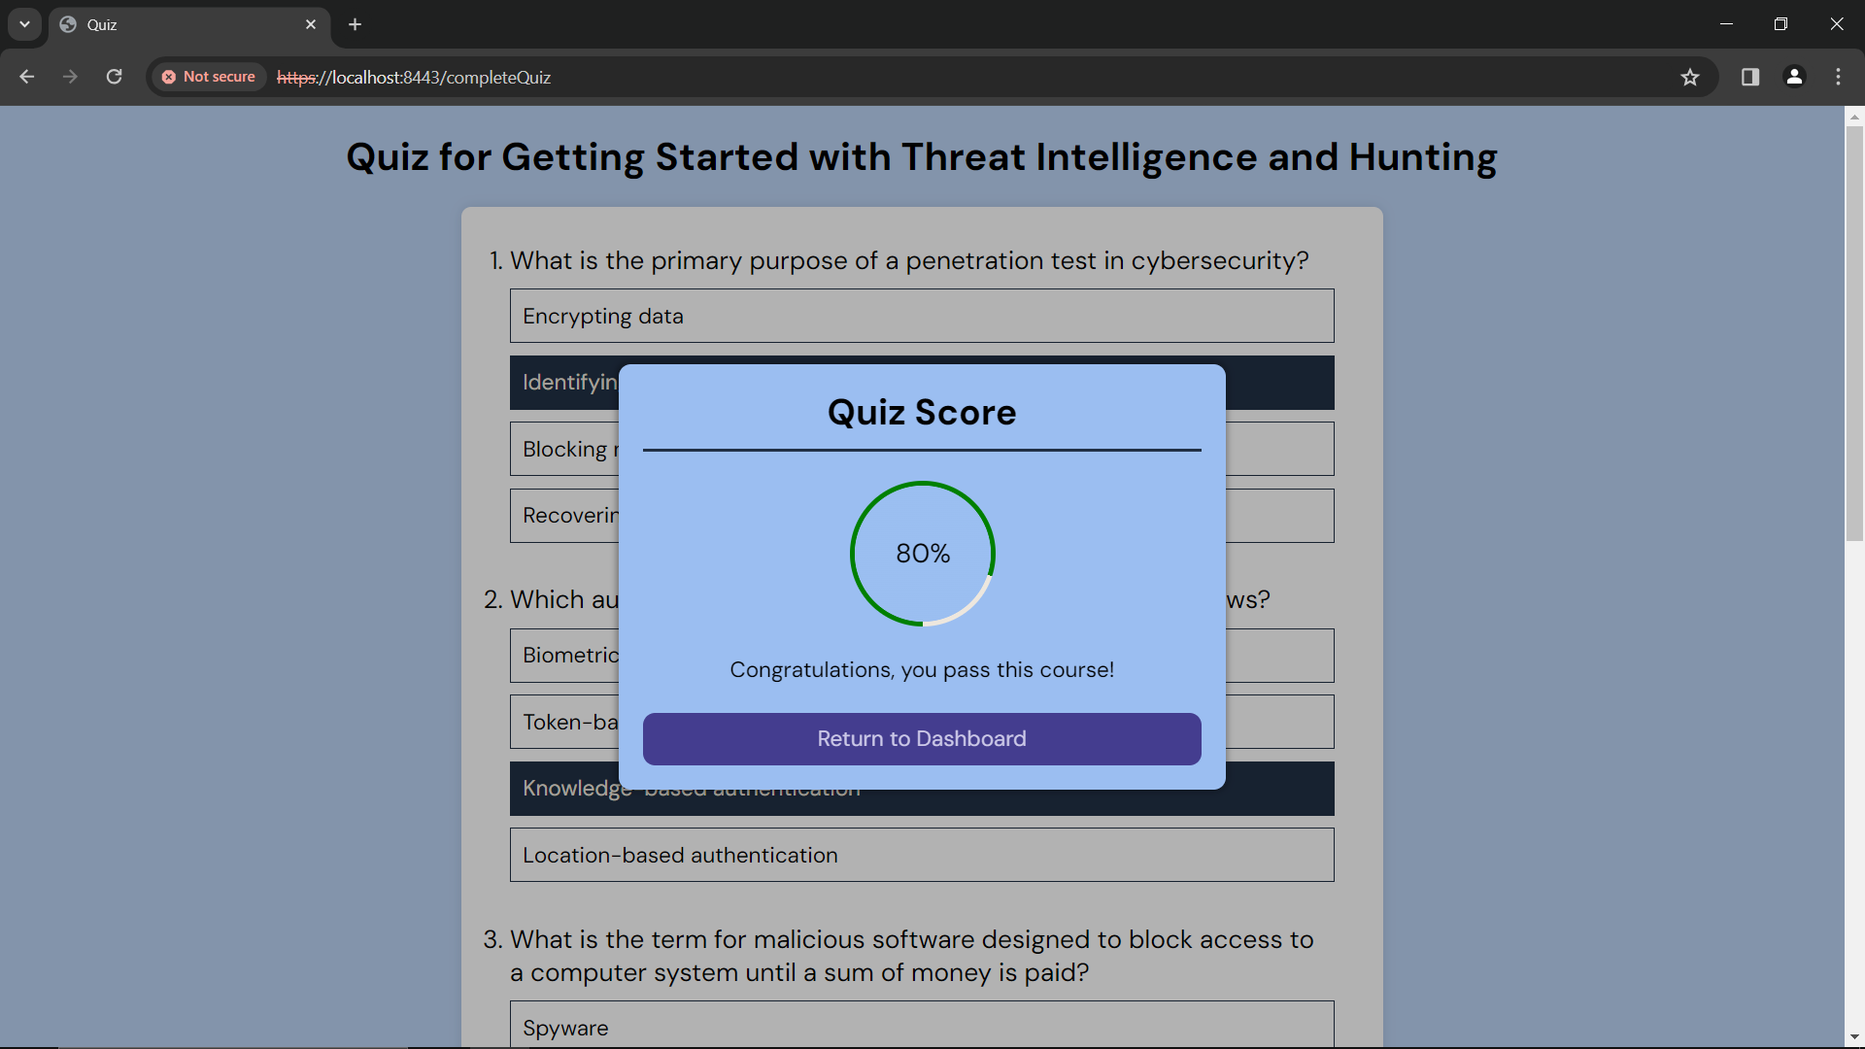

Click ***‘Return to Dashboard’***

Figure 22: Quiz - Passed

Once you have passed the quiz you will see the screen shown in Figure 22 (shown above)

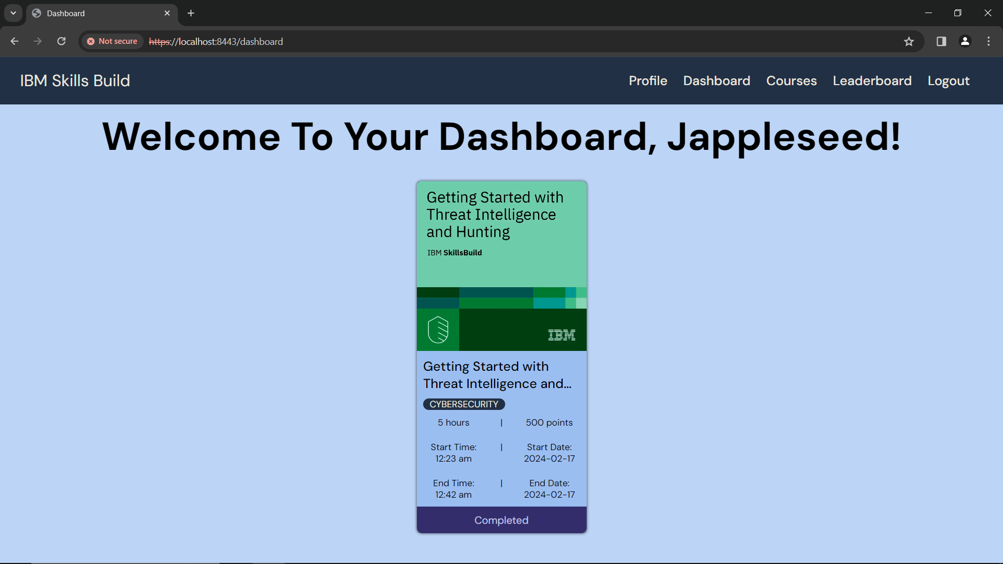

Figure 23: Dashboard - Completed Course

After you click ***‘Return to Dashboard’***, you will see the time and date when you passed the quiz and completed the course.

If you help with enrolling in more courses, head to the **Enroll in a Course** section under the **Courses** section in the user manual

# Courses

To access the courses page, use this link: <https://localhost:8443/courses>

On the courses page, you will see a Welcome message, with available courses that you can enroll in.

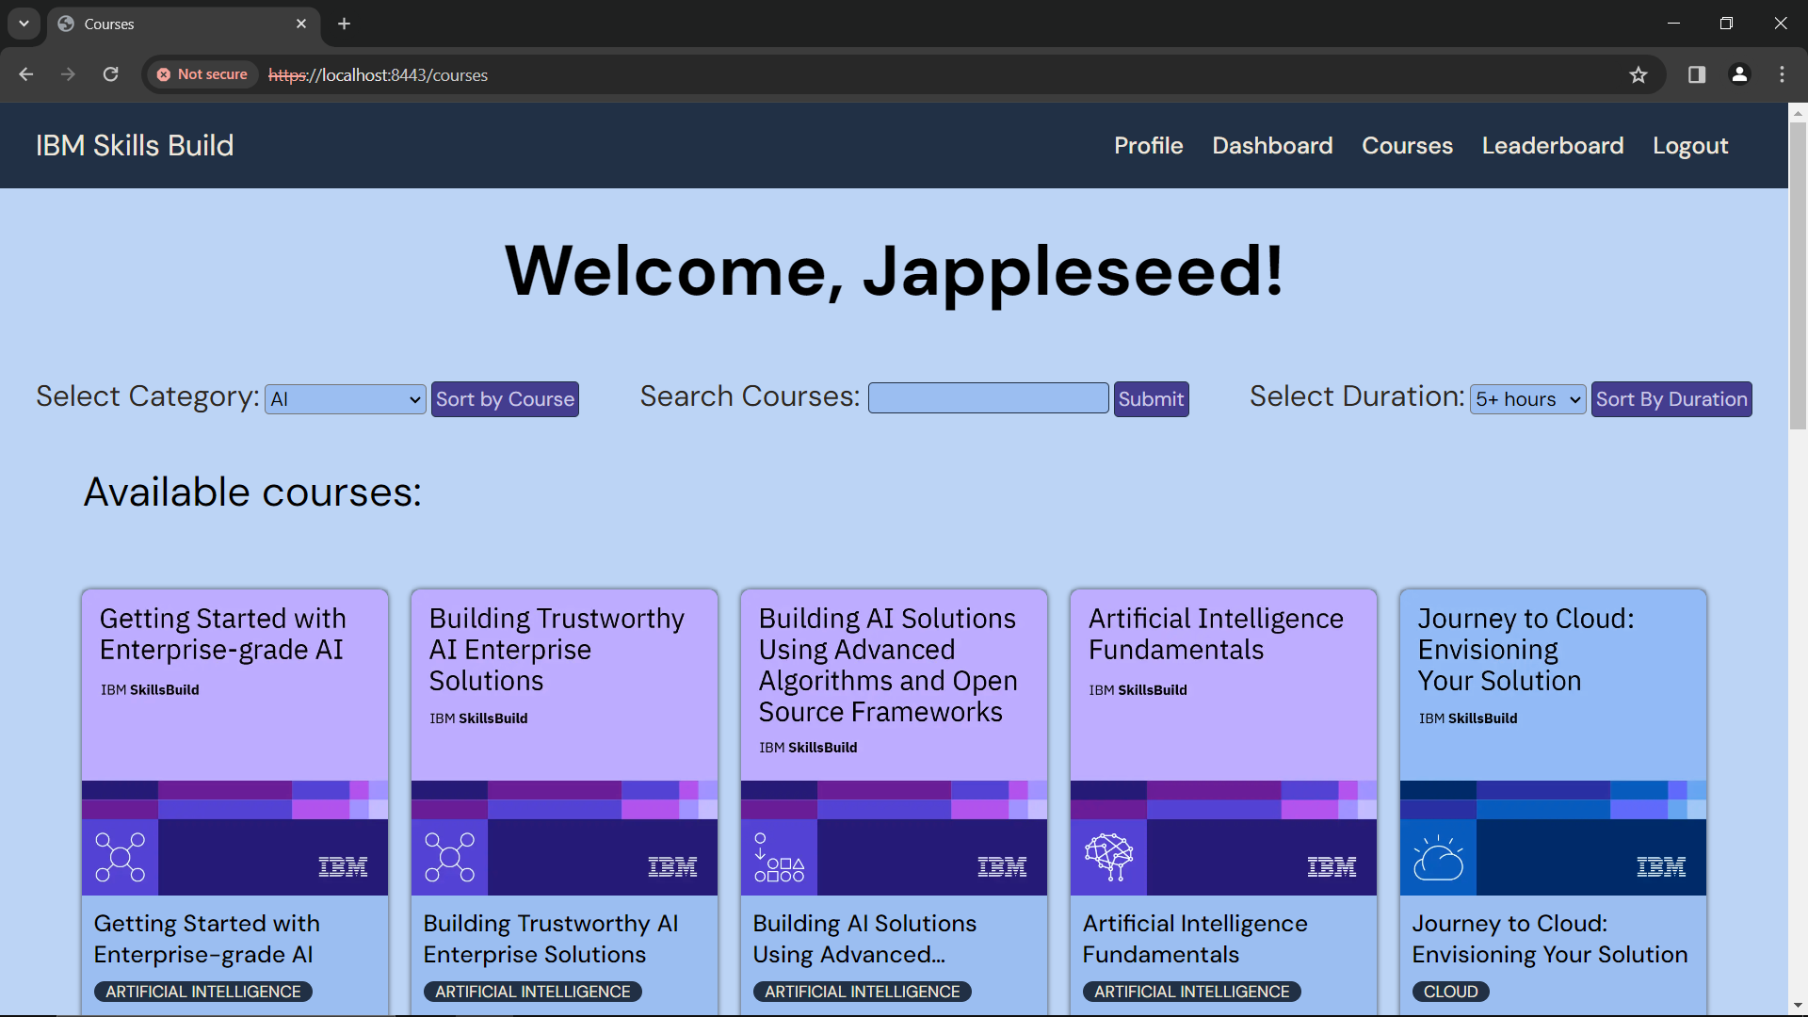

Figure 24: Courses

If you want to view courses you have already enrolled in, head to the ***‘Dashboard’***



To go to your Dashboard, click **‘*Dashboard’***

Figure 25: Courses - Dashboard

If you want help with your dashboard, head to the **Dashboard** section in the user manual.

## Enroll in a Course

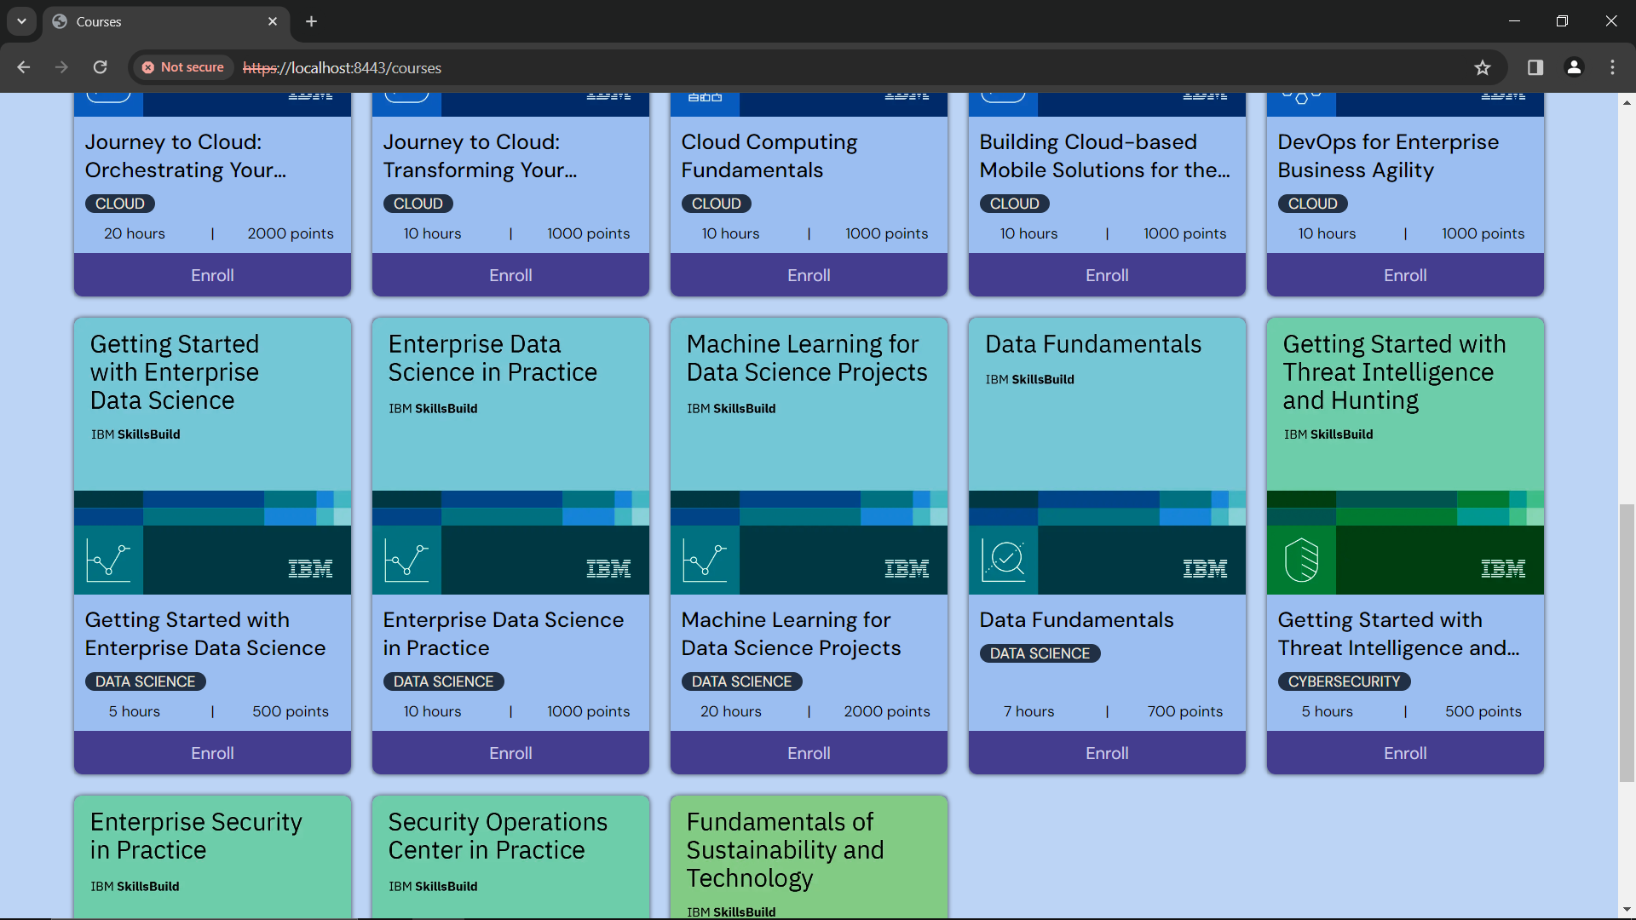

To enroll in course, click **‘*Enroll’***

Figure 26: Courses - Enroll in a Course

To enroll in a course of your choice, click **‘*Enroll’***

*Example: Course - Getting Started with Threat Intelligence and Hunting (shown in Figure 26 above)*

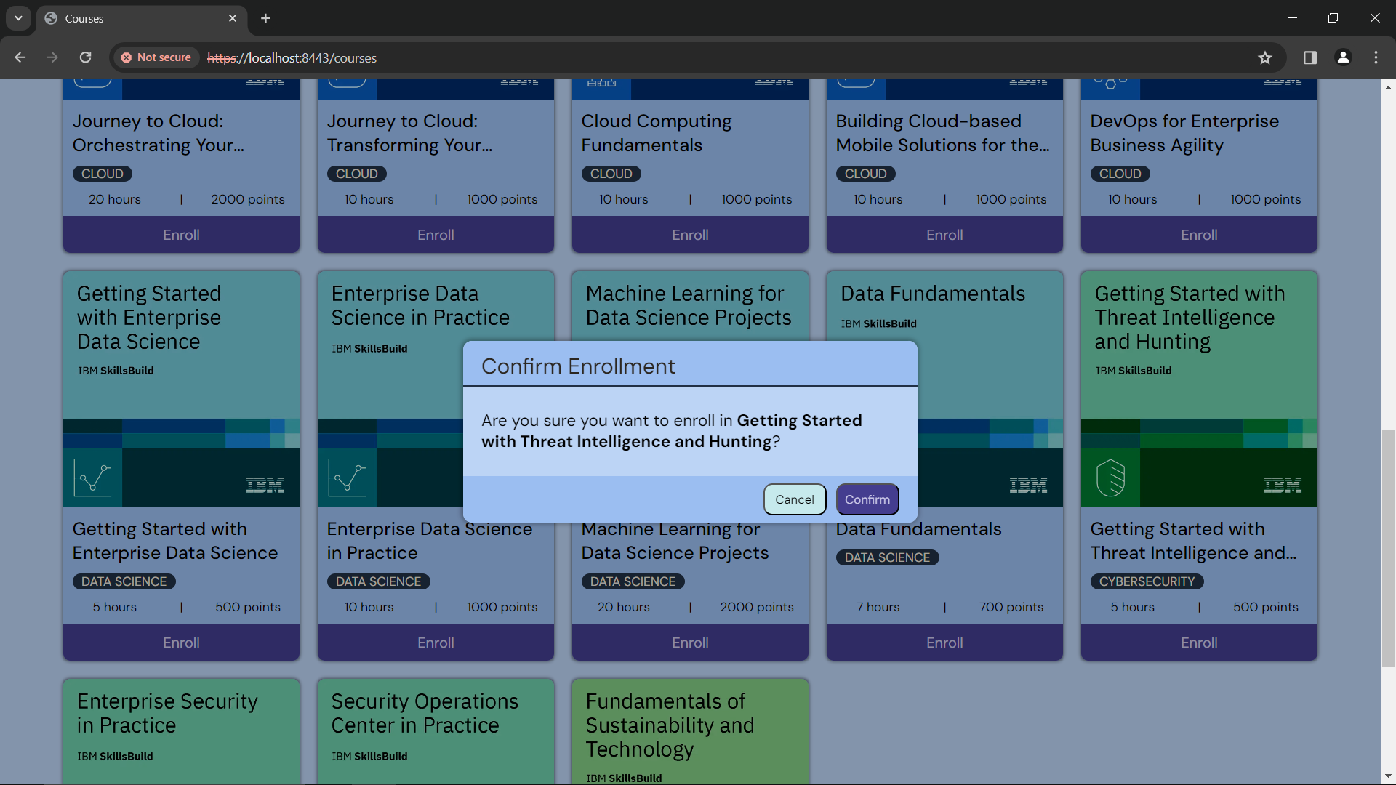

Figure 27: Courses - Enroll

After you click ***‘Enroll’***, you will see a popup that asks if you want to enroll in that course.

* If no, click ***‘Cancel’ –*** you will see the courses page again



Figure 28: Courses

* If yes, click ***‘Confirm’*** – you will see your dashboard with the course you enrolled in

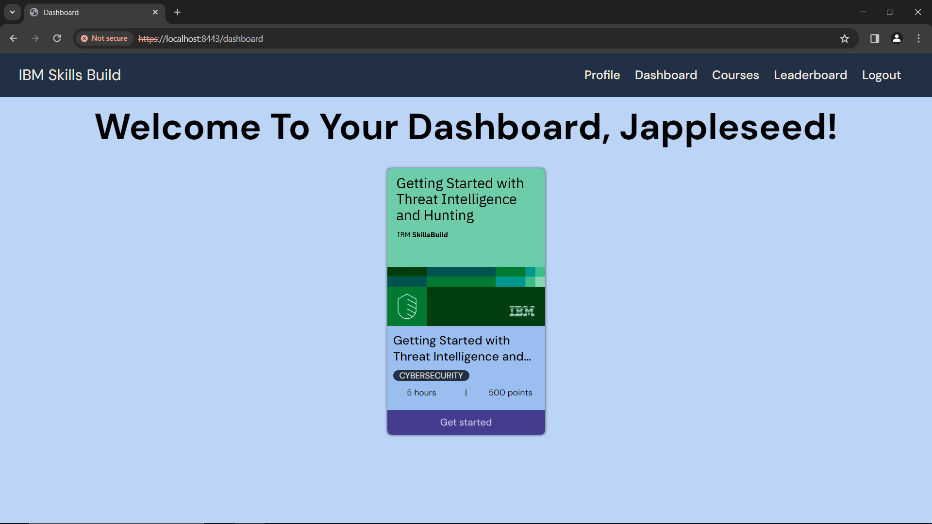

Figure 29: Dashboard

If you want help with your dashboard, head to the **Dashboard** section in the user manual.

## Filter Courses

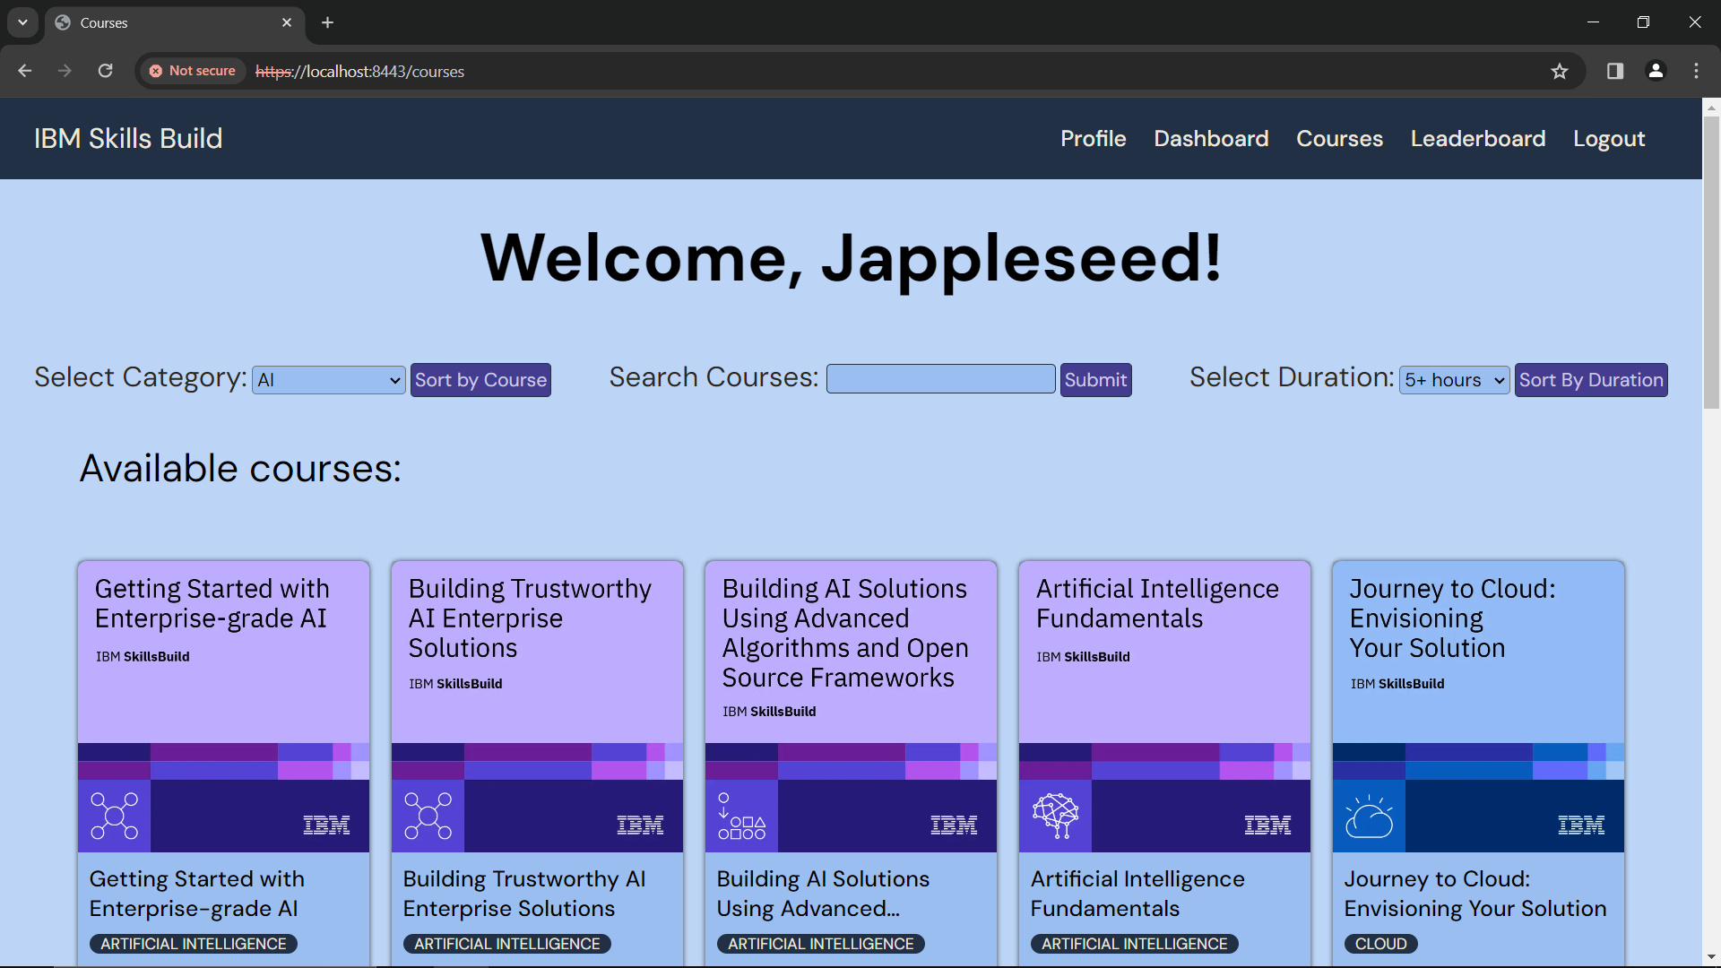

Filters

Figure 30: Courses - Filters

At the top of the courses page, you will see filters where you can filter available courses in 3 ways

1. **Category**

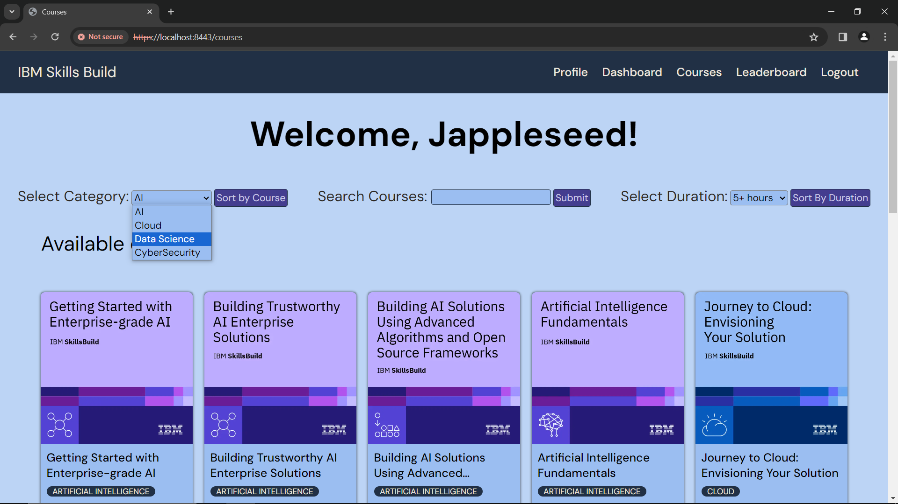

Figure 31: Courses - Filter by Category

Select your preferred category *(e.g. Data Science)* and it will display all Data Science courses.

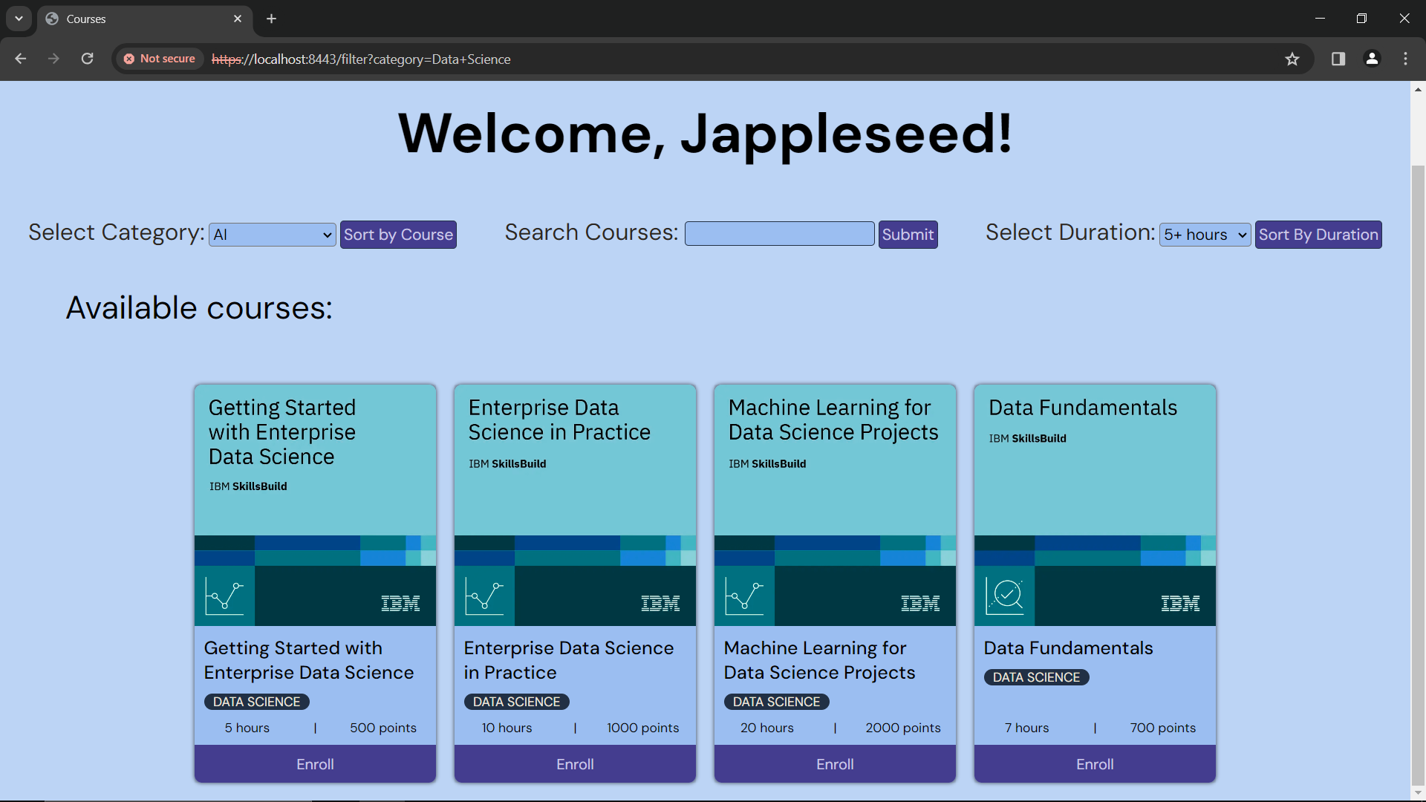

Figure 32: Courses - Filtered Data Science Category

You can now see the results of your filter by course category.

1. **Name**

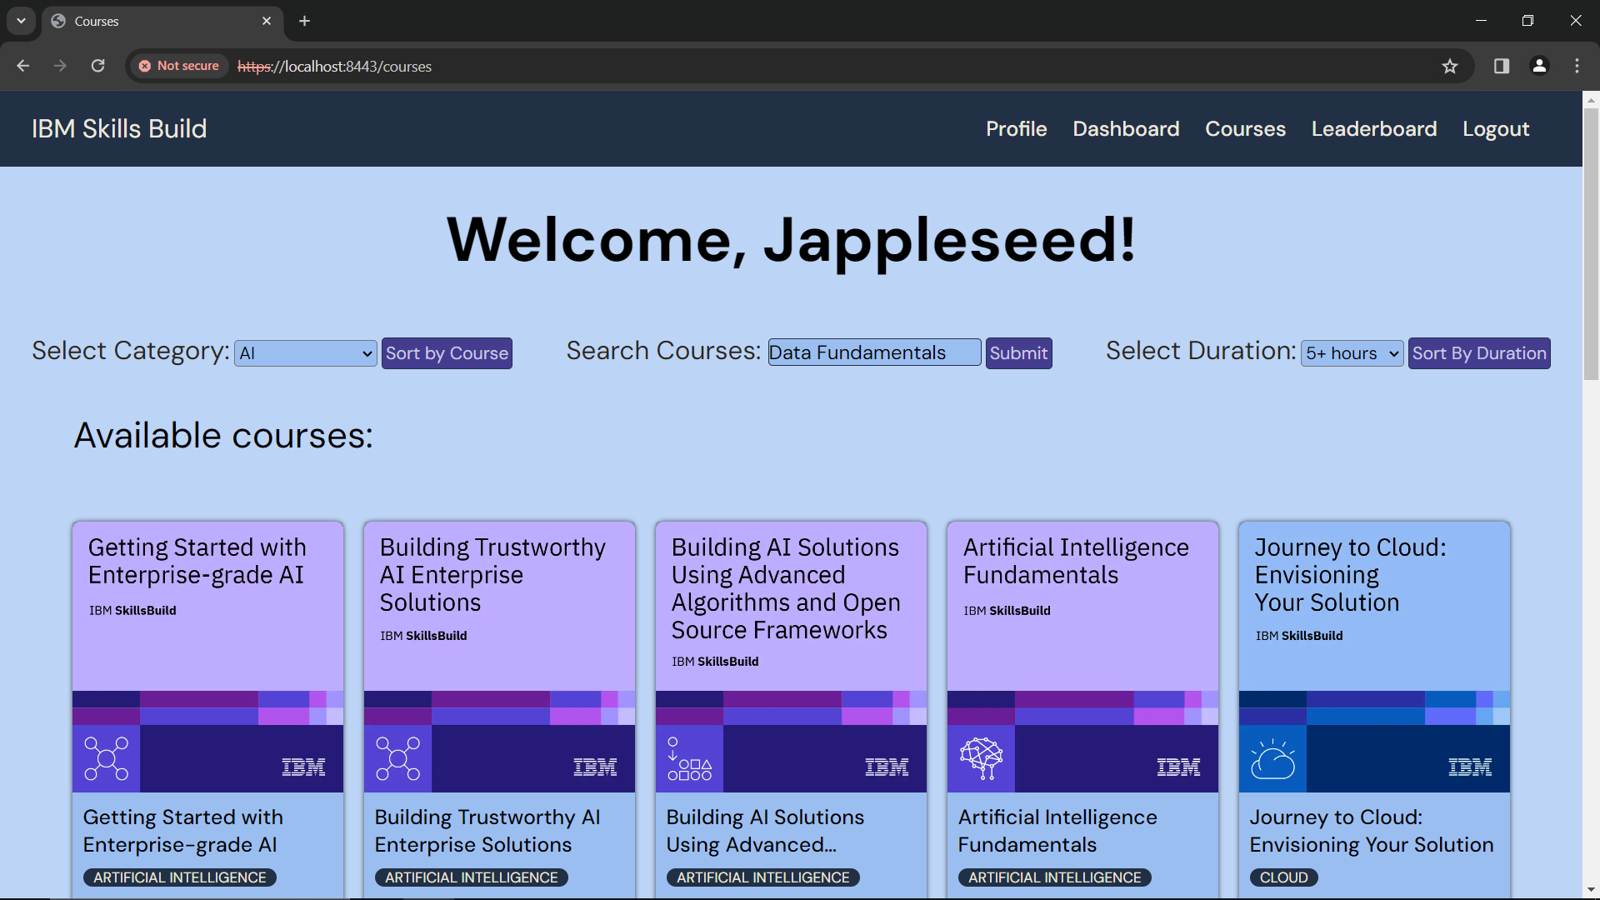

Figure 33: Courses - Filter by Name

You can search by course name, or keyword

Type in the search box *(e.g. ‘Data Fundamentals’)*

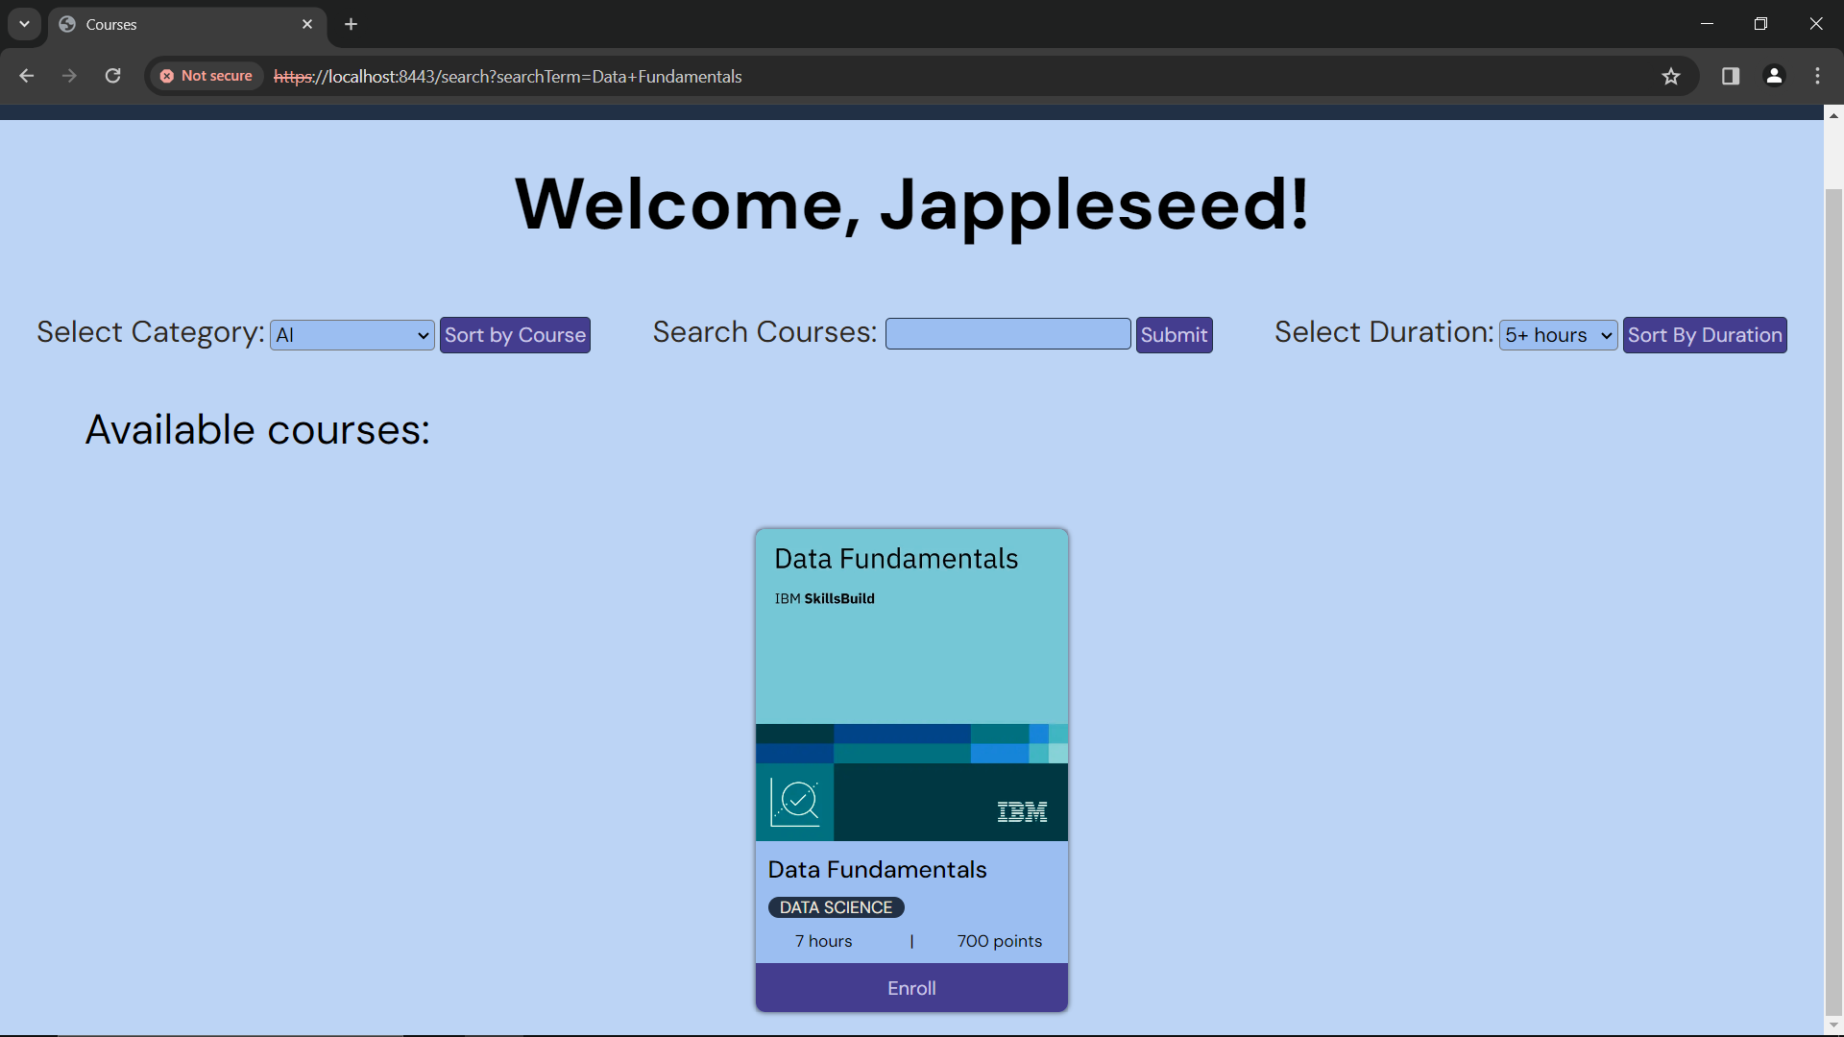

Figure 34: Courses - Filtered by 'Data Fundamentals'

You can now see the results of your search.

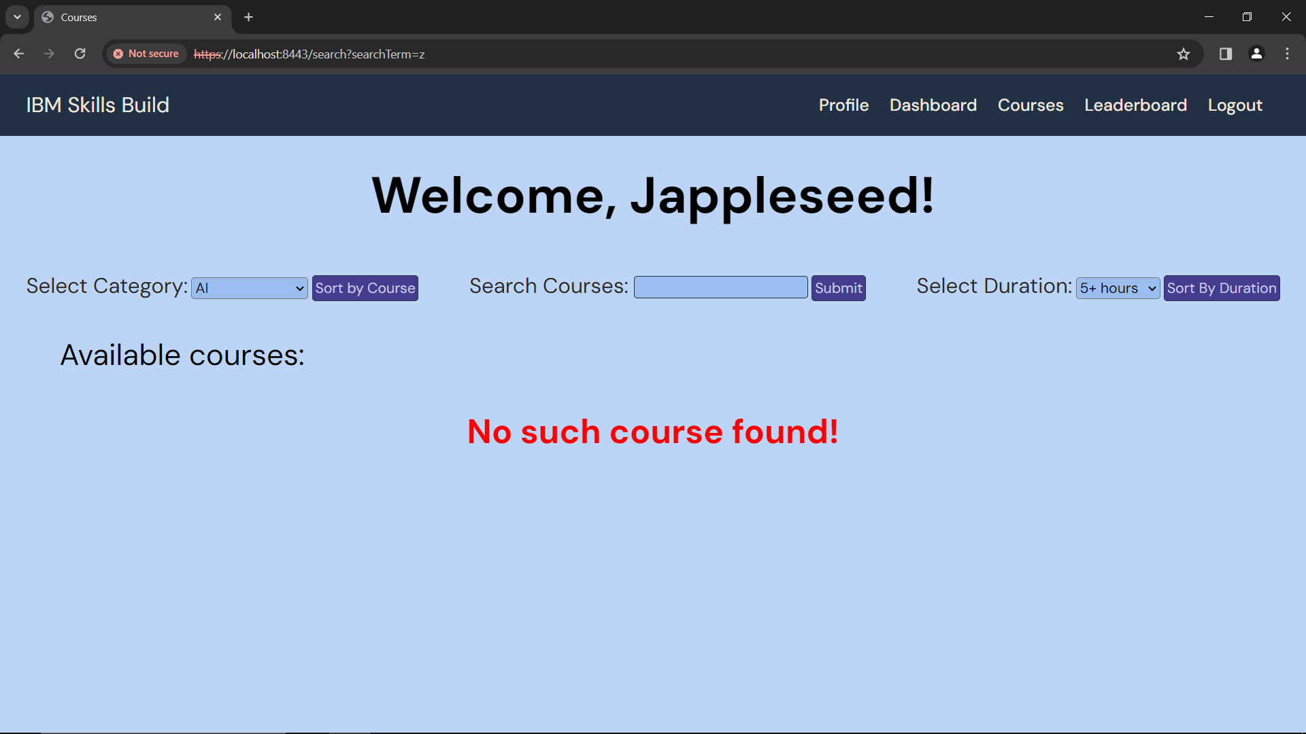

Figure 35: Courses - 'No such course found'

If your search returns the ‘No such course found’ message (as shown in Figure 35 – show above), try another keyword or phrase.

1. **Duration**

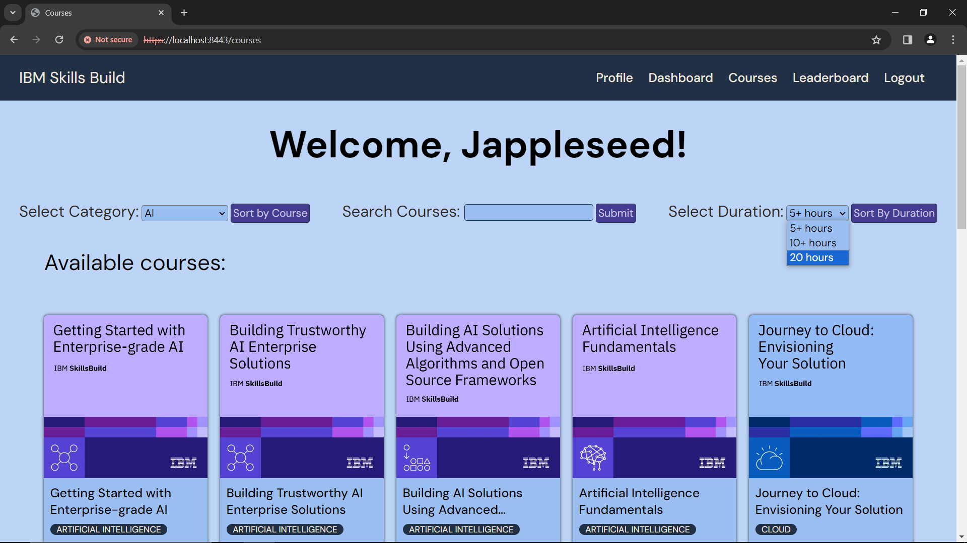

Figure 36: Courses - Filter by Course Duration

Select your preferred category *(e.g. 20 hours)* and it will display all courses with a duration of 20 hours.

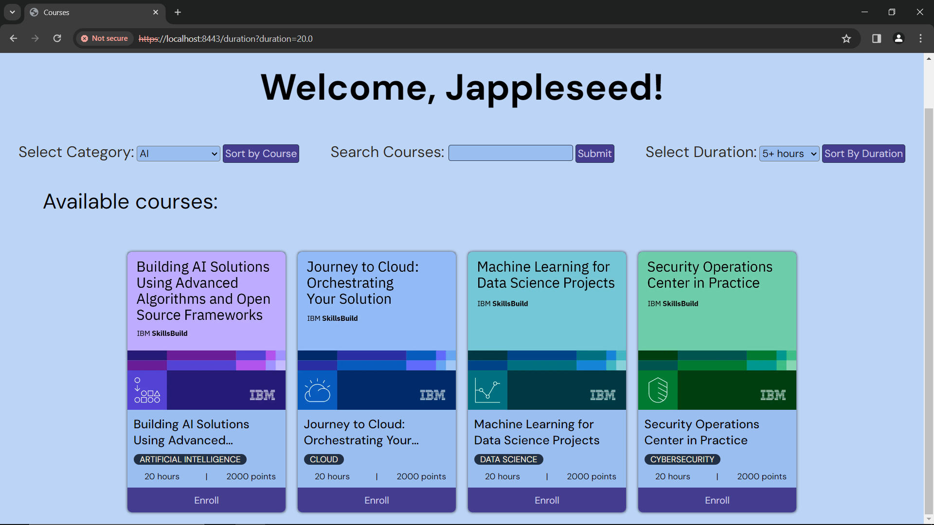

Figure 37: Courses - Filtered by Duration 20 hours

You can now see the results of your filter by duration.

You can now enroll in a course of your choice.

If you want help with enrolling in a course, head to the **Enroll in a Course** section under the **Courses** section in the user manual.

# Leaderboard

To access the leaderboard, use this link: <https://localhost:8443/leaderboard>

In the leaderboard, you will be able to see the top 5 users and their scores.

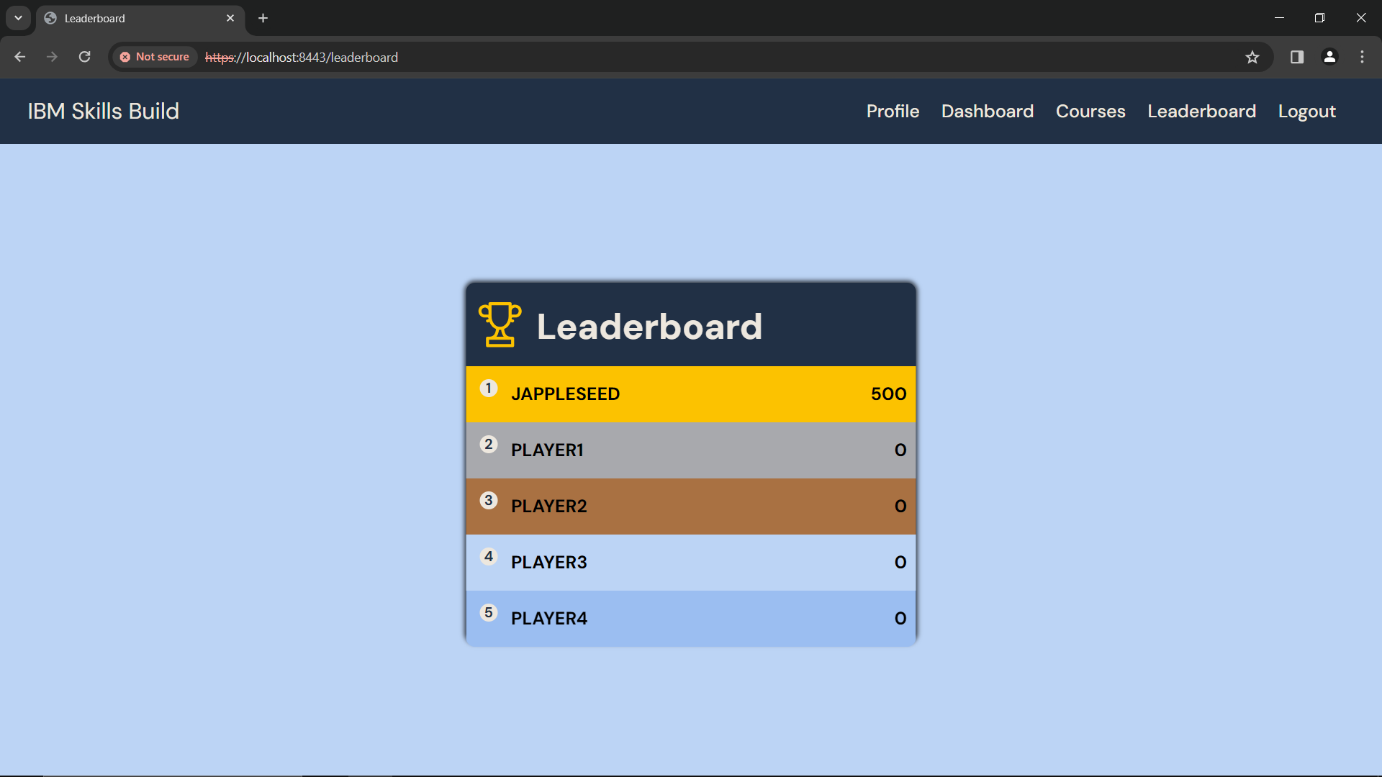

Figure 38: Leaderboard

As you complete courses (after getting at least 80% in the quiz) you will get more points.

* Points are calculated by the duration of the course
  + 1 hour = 100 points
  + 5 hours = 500 points
  + 20 hours = 2000 points

Complete more courses, to earn more points and move up the leaderboard.

# Logout



To logout, click **‘*Logout*’**

Figure 39: Courses - Logout

You will be able to see the logout option at the top of every page in the navigation pane.

After you logout, you will be taken back to the login page.



Figure 40: Login